RESUME

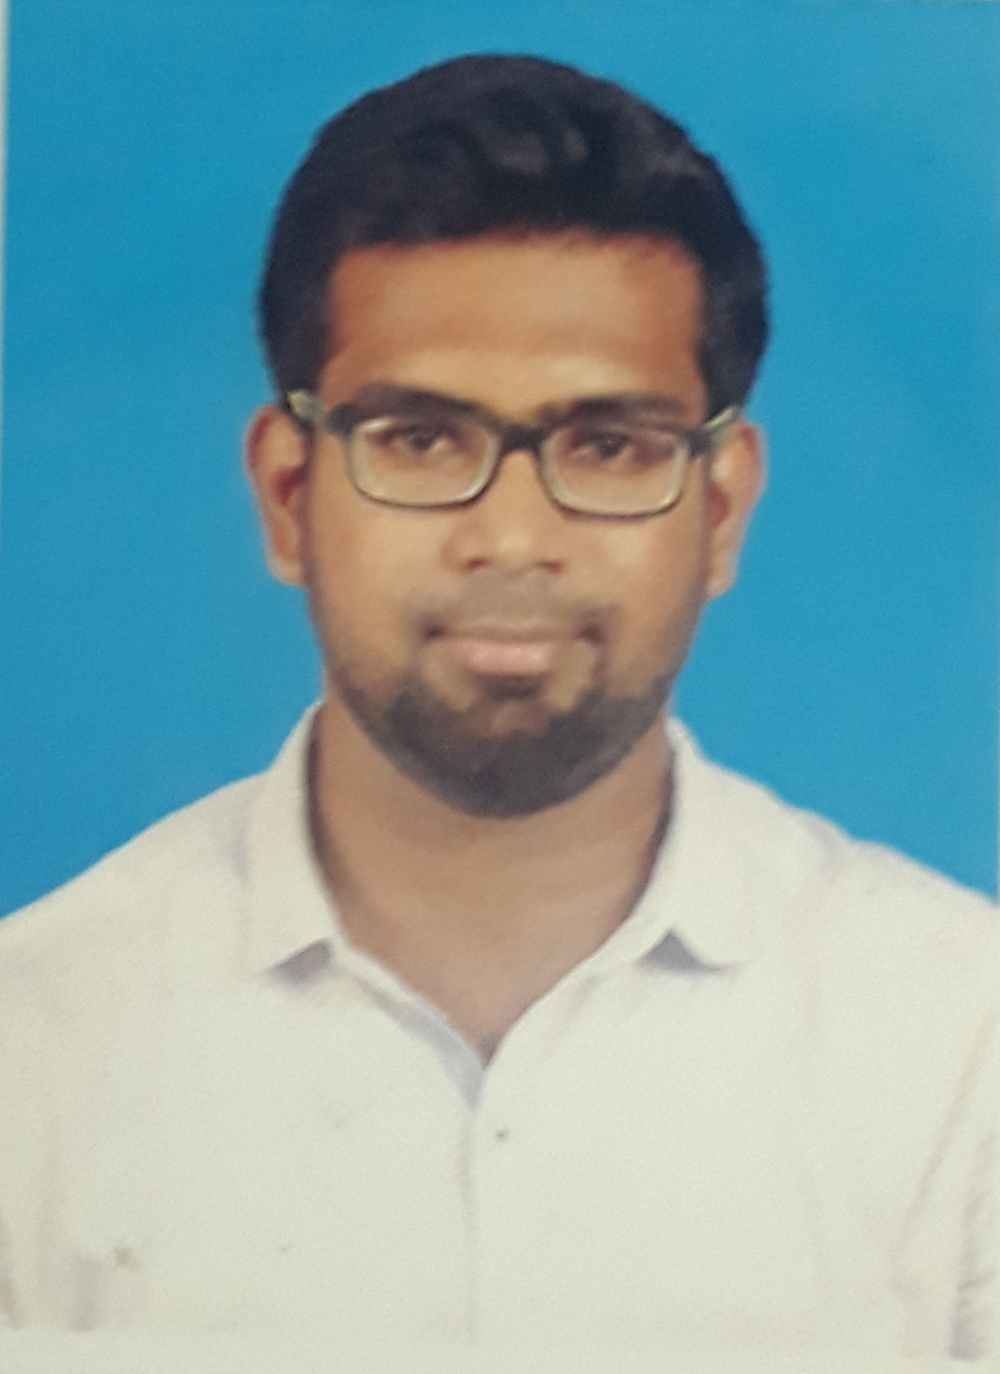
Mohamed
Mohamed.373086@2freemail.com

CAREER OBJECTIVE:
To secure a position of a Trainee where I can effectively contribute my skill, thereby expanding my knowledge, which helps to achieve the organization goals and a opportunity to measure
My individuality in a organisation.

PROJECT EXPERIENCE:

- Successfully completed a diploma project in Motorised ramming machine.
- Successfully completed a mini project in Solar tracking system.
- Successfully completed Engineering project on CYCLE TIME OPTIMIZATION OF
FORGED ALUMINIUM WHEELS IN WHEELS INDIA LIMITED CHENNAI

EDUCATIONAL QUALIFICATION:

COURSE | INSTITUTION | YEAR | MARKS
B.E(Mechanical engineering) | Anand institute of Higher technology | 2013-2016 | 6.3  (CGPA)
Diploma  In Mechanical Engineering | Panimalar Polytechnic college ,  Nelson Manikkam Road, Chennai-600029. | 2013 | 81.04 %
SSLC | Mohamed sathak Matriculation higher secondary school | 2010 | 58.2%

AREA OF INTEREST:

- Manufacturing Department.
- Quality Assurance Department.
- Tool Maintenance Department

CO-CURRICULAR ACTIVITES:

- Playing sports like cricket
- Listening to music

INDUSTRIAL VISIT:

INDUJA FOUNDRY ENOORE

WORK EXPERIENCE:

worked as a Production supervisor for a year at Sanjana metal ware India pvt .ltd

SOFTWARE SKILLS:
- 3D modelling software AutoCAD
- MS Excel

PERSONAL DETAILS:

Date of Birth 20.10.1994
Age 22.
Gender Male.
Marital Status Single.
Blood group B+ ve

I hereby confirm that the above mentioned information is true to best of my knowledge.

