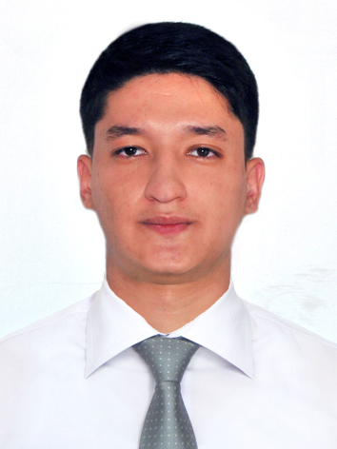  JAKHONGIR  JAKHONGIR.373091@2freemail.com  SKILLS  - Strong desire to learn and grow  - Commitment to the implementation of the requirements of work  - Understand personal and team roles  - Advanced sales skills  - Continuous learning and self-development  - Creative Problem-solving  LANGUAGE SKILLS  - English – Fluent  - Russian – Fluent  - Turkish – Basic  - Uzbek – Native  IT Skills: Advanced User, MS Office (Word, Excel), Web surfing and Google etc. |  |  | SUMMARY  I am an adaptable, hardworking and determined sales associate who owns excellent interpersonal skills and can thrive in a team. I have over 3 years of experience in retail industry and customer service. During my experience I have developed sales and problem solving skills and learned how to work harmoniously and effectively with customers.  WORK EXPERIENCE  Sales Associate, ALVON Fashion Boutique  Tashkent, Uzbekistan May, 2017 – Sep, 2017  - Provide customers with all required information about merchandise  - Explain the differences between various types of fabric  - Carrying out duties such as re-merchandising and up/cross-selling  - Create and maintain long-term relationships with regular customers  - Communicate with customers in order to assess and satisfy their needs  Sales Associate, KOTON  Samarqand Darvoza Mall  Tashkent, Uzbekistan July, 2016 – April, 2017  - Greet customers and offer them assistance  - Provide product, promotion and pricing information by request  - Assist in displaying merchandise  - Receive store deliveries  - Occasionally open and close the store  Sales Assistant, db BILCEE  Mega Planet Mall  Tashkent, Uzbekistan May, 2014 – June, 2016  - Welcome customers and determine their needs  - Present products and answer questions about items and pricing  - Explain the advantage and the use of product to customers  - Update job knowledge by participating in educational courses  EDUCATION  international hospitality and tourism management  “Management Development Institute of Singapore in Tashkent”  Tashkent, Uzbekistan 2016 – 2017  FOREIGN PHILOLOGY  The 2nd Academic Lyceum under Uzbek State World Languages University  Tashkent, Uzbekistan 2013 – 2016  REFERENCES  Available on request

