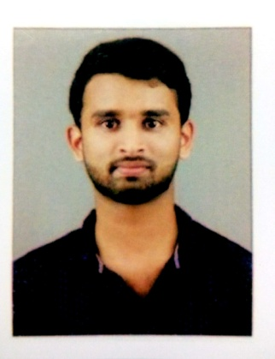
ANEES
ANEES.373095@2freemail.com

Objective:

To work with maximum potential in a challenging and dynamic environment, with an opportunity of working with diverse group of people and enhancing my professional skills with learning and experience for career growth.

Professional Qualification:

- ELECTRONICS AND COMMUNICATION ENGINEERING from (2014-2018) Nehru college of engineering and research center Pampady ,Thiruvilawala ,Thrissur

Technical Skills:

- IN-Plant training from DRONACHARYA ELECTRONICS SYSTEMS ( DES ).
- Internship from KELTRON KNOWLEDGE CENTER.
- Member and active participant of THE INSTITUTION OF ELECTRONICS AND TELECOMMUNICATION ENGINEERS (IETE).

Curriculum Achievements:

- Active participating on annual day celebration BLOOM NCERC.

Educational Qualification:

Qualification | College Name | Board/University | Year of Passing | Marks (%)
B-Tech | NEHRU COLLEGE OF ENGINEERING AND RESEARCH CENTER PAMPADY | UNIVERSITY OF CALICUT | 2018 | 7.0
H.S.C. | MOUNT SEENA PUBLIC SCHOOL PATHIRIPALA | CBSE | MARCH,  2014 | 75
S.S.C | MOUNT SEENA PUBLIC SCHOOL PATHIRIPALA | CBSE | MARCH,  2012 | 9.6

Projects :

MINI PROJECT:
REAL TIME MOBILE CHARGING USING WALKING MOVEMENT
- Our project represents an idea of walking based wearable piezoelectric device that prrovides an alternate means for powering mobile phone batteries.
- As per study of biomechanics, we came to realize that ground reaction force(GRF) exerted from the foot, when converted into voltage gives enough power supply to run a device.
- Piezoelectric material have the capability of absorbing mechanical energy from surroundings, especially vibrations and transform it into electric energy and that can be used as a power supply in real time to other appliances

Internship:

IN PLANT TRAINING PROGRAMME DRONACHARYA ELECTRONICS SYSTEMS ( DES ).
- At 6th semester btech I has successfully completed the in plant training programme conducted by
Dronacharya Electronics Systems ( DES ),Ernakulam for five days from 05/09/2017 to 19/09/2017.

INTERNSHIP FROMKELTRON KNOWLEDGE CENTER.
- 3 days internship programme at keltron knowledge center
- It expertise on introduction of embed system.
- The basic knowledge about hardware and software using in embedded system.
- Different types of controllers like Atmel 8051 ,PICfamily,application of all microcontrollers in
different projects.
- Programming in embedded c.

Personal Detail:

Date of Birth : 09/02/1996
Work Experience : 0
Languages Known : ENGLISH, MALAYALAM and TAMIL.
Passport : YES
Marital Status : SINGLE

Declaration:

I do hereby declare that the particulars of information and facts stated here in above are true, correct and complete to the best of my knowledge and belief.

