Resume

Anjali
Anjali.373122@2freemail.com

Objective

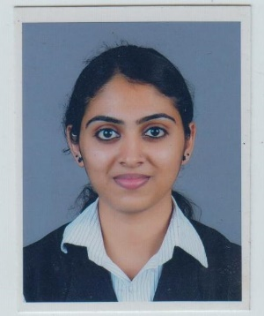

Interested in a long-term relationship with a reputed firm to share my valuable experience. I am optimistic about putting in exceptional performance in any kind of challenging environment as my endeavor in the profession is to excel in the responsibilities entrusted by my organization.
Would like to pursue a multi-skilled career.

Experience

2015 – 2017 Accenture Services Pvt Ltd

Description: it’s a global management consulting and professional services company. It provides strategy, consulting, digital, technology and operations services. It’s a Fortune Global 500 company.
Profile

Date of Birth
13 August 1992

Visa Status
Dependent Visa

Designation: Application Development Analyst

Responsibilities:
- Worked as a part of CRM (Customer Relationship Management) team.
- Have knowledge in Oracle’s Siebel CUSTOMER RELATIONSHIP MANAGEMENT(CRM) solution.
- Dealt with business clients and high level workloads within strict deadlines.
- Have worked in Siebel application and SQL developer.
- Worked on RTC tool-Version control for deployment activities.
- Played a major role in defect fix built and unit testing for releases.
- Performed remediations using Tibco Designer (automation tool) for aligning data.
- Have a hands-on experience with Siebel configuration such as Applet, BC, &WF etc.

Professional Certifications

Successfully completed Accenture Foundation training program.
In-plant training on TELECOM TECHNOLOGIES conducted by BSNL (Bharat Sanchar Limited)
Basics of python training conducted by IEEE

Education

2010 – 2014 Bachelor of Technology (BTech) in Electronics & Communication,
M Mahatma Gandhi University

Professional skills

- Have knowledge in Oracle’s Siebel CUSTOMER RELATIONSHIP MANAGEMENT(CRM) solution.
- Knowledge in Microsoft Office Excel, Word & PowerPoint applications.
- Basic knowledge of PL/SQL .
- Knowledge in windows XP/7,8 & 10.
- Have knowledge in Siebel Technology.
- Knowledge in inserting, deleting & getting data from database using SQL Developer.

Conclusion

I Anjali do hereby declare that all the particulars and information furnished
above are true to the best of my knowledge.

