 | RANJITHKUMAR
7/14/2017
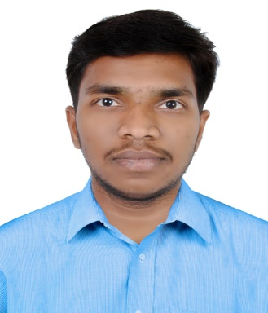 | Ranjithkumar.373123@2freemail.com

Objective

Seeking a position to utilize my skills and abilities in the Electrical Field that offers professional growth while being resourceful, innovative and flexible.
experience

1.Electrical Technician - Electrical Maintenance

Eternity technologies FZ LLC, A GROUP OF AL DOBOWI LLC,
UNITED ARAB EMIRATES.

From January 17,2015 - To June 13,2017

- Electrical Technician work on round the Battery manufacturing unit.
- Identified and resolved causes of equipment malfunctions.
- Good working knowledge in siemens, Mitsubishi, Allen Bradley, Omron PLC.
- Good knowledge in electrical diagram analysis.
- Preventive and Breakdown maintenance of Die casting molding machine and assembly automation machines like HADI, SOVEMA, EIRICH MIXERS etc.,
- Coordinated with HADI, SOVEMA teams for Erection and installation of new machines and control panels.
- Assemble, Installing, testing and maintaining, wiring on electrical equipment’s, appliances, and using hand tools and power tools.

2. Electrical Technician - Electrical Maintenance

Freins Engineering LTD, CHENNAI, INDIA.

From 25 February 2013 To 24 December 2014

- Responsible for maintaining and repairing CNC machines required in the day to day working
- Responsible for power supplier, generators, distribution of loads plus cabling factory, accommodations, offices (power supplier, refrigeration, lighting, air condition….)
- Preventive maintenance of HT-11KV To 440V Transformer, SSBs, Power distributers and Panel boards etc.,
- Modifications of machines to improve productivity, safety etc.,
- Trouble shooting of all electrical circuits, control and protection of electrical machines for safety purpose.
- Operation and maintenance of HT and LT panels.

3. Electrical Technician - Electrical Maintenance

Lucas TVS Limited, CHENNAI, INDIA.

From 10 October 2011 To 09 October 2012

- Electrical preventive maintenance of CNC machines,
- Breakdown maintenance of CNC machines.
- TPM activities like abnormalities correction.., tag removal etc.,
- Daily maintenance of utility equipment’s like compressor, generator, Air conditioners, Air drainers etc.,
- Energy saving activities.
- Operation and maintenance of power plant and sub-station.
- Planned preventive maintenance (PPM) works done as per a schedule.
skills
- PLC
- DCA(MS-OFFICE)
- Auto CAD(ELECTRICAL)
QUALIFICATION
1.Diploma in electrical and electronics engineering
85.46% first class with distinction
sri adhisankarar polytechnic collage-triCHY.

From 2009 To 2011

2. HIGHER SECONDARY SCHOOL

65.08 % FIRST CLASS

GOVERMENT HIGHER SECONDARY SCHOOL – ANDIMADAM.

From 2007 To 2009

3. SECONDARY SCHOOL LEAVING CERTIFICATE

64.60 % FISRT CLASS

GOVERNMENT HIGH SCHOOL – KOOVATHUR.

From 2006 To 2007

PERSONAL DETAILS

Date of Birth 17 June1992

Blood group B positive

Marital status Single

Nationality Indian

Language’s known English, Tamil, and Hindi.

DECLARATION

I hereby declare that the information furnished above is true to the best of my knowledge.

