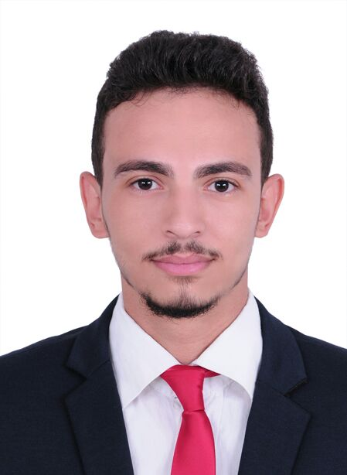
Fikry

E- Mail : fikry.373127@2freemail.com

To attain a challenging position from where I can regulate the multifunction of the company and prove my efficiency.

Professional Profile:
- Professional Qualification : Bachelors in management information systems.
- Specialised certification in Surveying and Mapping.
- Self-Motivated, Multi-tasking, Quick learner & a good Team Player
- Extensive knowledge of land surveying methods and measurement practice
- Outstanding analytical and land records checking skills
- Proficient with standard safety policies and procedures

Professional Achievements:
- Developed, implemented, monitored, and provided progress reports on projects
- Studied the design contract and documents and presented reports
- Successfully worked with AutoCAD 2D
- Working knowledge of MS Office suite and other software applications

CARREER :

ELELFY SURVEY, General Surveyor (15-05-2017 to 20-07-2017)
- Operating Global Positioning Systems (GPS) for tracking and measuring areas
- Implemented Visual Basic for applications for AutoCAD
- Worked with Total Station , Level, GPS NAVIGATION
- Prepare and maintain sketches, maps, reports, and legal descriptions of surveys in order to describe, certify, and assume liability for work performed.
- Verify the accuracy of survey data, including measurements and calculations conducted at survey sites.
- Record the results of surveys, including the shape, contour, location, elevation, and dimensions of land or land features.
- Calculate heights, depths, relative positions, property lines.

Educational Qualification:
- Bachelors in Management information systems.
Higher Institute of Advanced Studies Affiliated to Cairo University,Egypt
- SPECIALISED CERTIFICATE IN SURVEYING AND MAPPING : EGYPT 2017
Accredited by AL MASTAQBAL INSTITUTE OF QUALITY , DUBAI ,UAE
- Proficient with MS WORD, EXCEL AND POWERPOINT.

Personal Information:

Date of Birth : 1st october-1993
Nationality : Egyptian
Language : English, Arabic
Current Status : Immediately available. Long term Visit Visa

