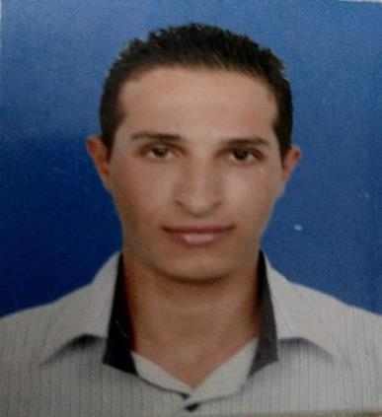
Personal Information:

Name: Ahmad

Gender: Male.

Nationality: Jordanian.

Contact Details:

Address: Dubai - UAE.

Email address: Ahmad.373193@2freemail.com

Higher Education:

Bachelor degree of Computer Science at Birzeit University (2009 - 2014).

Certified Courses & Projects:
- Leadership course:

54 hours of tanning and participated in Best Business Plan Competition at the Najjad Zeenni IT Center of Excellence.
- Networking:

40 hours CCNA: Network Fundamental.

40 hours CCNA: LAN Switching and Wireless.

40 hours CCNA: Accessing the WAN.

Letter of Recommendation from cisco academy

- Web Development:

- Joomla framework, Drupal CMS and WordPress.

- Databases:

- MYSQL (Pharmacy backend application), Using JAVA
- Developed Desktop application (Pharmacy Updater Database) using C#.

- Dot Net:

  - Developed asp.net and C # (E-commerce online reservation system).

  - Developed asp.net and C# (Online Reservation System for medical infrastructure).

  - Developed Content Management System- CMS
- Android Development:

  - Developed a Best route for medical infrastructure using Dijkstra algorithm.

  - Developed a Speed Car Application.
  - Developed a dentist Clinic Application.
- Windows Phone Development:

- Developed a Temperature Converter.

- Developed a Trip Advisor.

- Developed Quran Kareem.

Voluntary & Training:

- Networking wireless at Gemzo Technology (07/2012-11/2012).
  - Computer maintenance and wireless home appliances.

  - Installation of Internet subscriptions for home.

- Microsoft Students Partner (MSP) at Palestine (02/2014-01/2015):
  - msdn subscriptions from Microsoft &Microsoft Student Partners Certification.

Experience:

- Instructor of ASP.NET & C# Data Structure at Universal Technical Institute–UTI (11/2012-06/2013).
- Software Engineer at Ideas Creative IT Solution (02/2014-11/2014).
- Technical support/ SMB Client at Etisalat UAE – Dubai (11/2014-06/2015).
- Software Developer & Systems Analyst at New Soft for Programming and Information Technology (06/2015- 04/2017).

Software Skills:

- Solid Experience in Data Structure and OOP in Java , C#,
- Sloid Experience in ASP.NET Framework , ASP.NET Core, MVC,
- Android, Windows Phone, Smart device, Entity Framework,

- Devexpress for ASP.NET & Mobiles, Telerik ASP.NET,

- Deep knowledge in JavaScript, Angular JS, JQuery,
- PHP/MYSQL, Oracle10g, Node.JS.
- Solid Experience in MS Sql Server, PL/ SQL, Stored Procedures, n-Tiers,
- Solid Experience in HTML, CSS 3, HTML5, XML, Ajax, Bootstrap, responsive site, Crystal Reports, Jasper reports.

- Self-learning of Glup, Web-Pack, React, Progressive web apps, SPA, NPM, and other technologies, VB.Net, ORMS and light speed, Reset, RPC Graph-QL
- Familiar with web application security oAuath2, Open Id connect,
- Solid Experience with wep/ desktop service , unite test, integration testing,
- Design patterns, SOAP, windows azure cloud computing.
- Solid experience in Technical Support.

Technical Skills:

- Solid experience in SQL server 2012Experss.

- Solid experience in Visual Studio 2008/2012 /2013/2015.

- Excellent knowledge of Wamp server.
- Xamarin Studio for mobile development.
- Driver license.

Work Shops & Events (2012 & 2014):

- Top Ten Newest Feature Event (2012).

- Deploying Wakanda Apps to the Cloud (2012).

- Data Modeling II (2012).

- Deploying Wakanda apps to the Cloud (2012).

- Global Windows Azure Boot Camp Palestine (2014): this event was at AL-Najah National University and so this event about windows azure and how to build website on clouds by using windows azure, and I got the certificate of Participation.

- Imagine Cup event (2014): Participated with Microsoft Imagine Cup Competition with Certification at Birzeit University.

- Microsoft Geek Idol (2014): Participated with Microsoft Geek Idol Competition with Certification at Al-Quds University.

- Microsoft Startup Day (2014): I organized the event of Microsoft Startup Day at Ministry of Telecommunication and Information Technology.

Graduation Project:
The project has two parts: web application using asp mvc and mobile application using android, so the project called (Online Reservation System and best route for the Medical infrastructures), the web application aims to make an appointment for the patient to reserve time with doctor and other processes, the mobile application aims to find the shortest path between person’s location and the nearest medical center using Dijkstra algorithm, and also the mobile application is associate with web application in reservation.

Operating Systems:
- Windows OS.

- Ubuntu.

- MAC.

Languages:

- Arabic: Native language.

- English: Excellent writing, reading and very good speaking.

