Prabhat
Prabhat.373195@2freemail.com
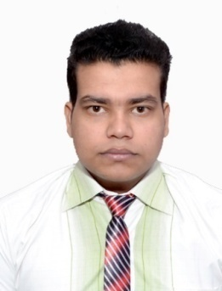
Objective Statement
Motivated and detail-oriented accountant with 2 years general accounting experience offers the following skills and experience:
- Solid working knowledge of MS Office
- Administration of accounts receivable and accounts payable
- efficient maintenance of the integrity of general ledger accounts
- Able to accurately gather, interpret and analyze financial data
- excellent organizational skills with demonstrated ability to effectively prioritize to meet strict deadlines
- Proven ability to quickly learn and use new technologies and tools
- Very good knowledge of VAT(value added tax)
- Expert in tally ERP 9
- Expert in MS Excel
Currently looking for a suitable position in accounts department with an exciting & ambitious company

Academic Qualifications -
- (2009-2010)10th from Army public school Jhansi Cantt Uttar Pradesh scored 70 percentile
- (2012-2013)12th from Mahatma hansraj public school Jhansi scored 65 percentile
- (2013-2014)Cleared First level of Company Secretary with exemption in three subjects from the Institute of Company Secretaries of India
- (2104-till time)Pursuing for Executive level of Company Secretary from the Institute of Company Secretaries of India
- (2014-till time)Pursuing for Bachelor of Commerce (Corporate affairs and administration) from Indira Gandhi national open university New Delhi, India

Work Experience-

M/S World capture New Delhi, India
(Event Management Company)

June 2015 to November 2016

Position: junior accountant
- Duties
- Writing up forms and manuals for accounting and bookkeeping personnel.
- Collecting raw financial data.
- Prepares journal entries, cash, and inter-fund transfers.
- Accurately and promptly processing documentation.
- Preparing all kinds of invoices in Tally 9
- Bank reconciliation

Skills-
- Tally ERP 9 (Expert)
- MS Excel (intermediate)
- Sage 50 (learning)
Personal Details-
- Nationality: Indian
- marital status: Single
- DOB: 27 July 1994
- Visa Status: Visit Visa (expires on 16th oct’2017)
- Birth place: Saharsa Bihar, India
- Mother tongue: Hindi & maithli
- Language: English
I hereby declare that the details furnished above are true and correct to the best of my knowledge and belief and I undertake to inform you of any changes therein, immediately
.

