Ahmed
Ahmed.373201@2freemail.com
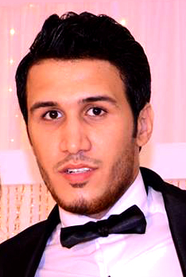

- EDUCATION:
-School:Hadayk Al Maadi ExperimentalSecondaryLanguage School.
-University Degree:Ain Shams University- Faculty of Commerce.
-Major:Business Management.
-Grade Point Average(GPA):Good.

- PERSONAL DATA:
-Date of Birth: 18/12/1989.
-Place of Birth:Cairo – Egypt.
-Religion:Muslim.
-Marital Status:Married.
-Military Status:Exempted.

- COMPUTERSKILLS:

-Well-acquainted with: XP,Vista, WIN7, WIN 8.
- MS Word, MS Excel,MS Power Point, MS Outlook ,MS Access.
- Internet Browsing and E-mailservice.
-Working knowledge of Most Windows Operating System.

- EXPERIENCE:

- Ben Laden Group In KSA
- Job description: Document Controller senior.
- Department: Document Control Management.
- From:2011.Till:2016.

- Raya Contact Center (Etisalat Project)
- Job description: Call Center Agent.
- Department: Etisalat Company Project.
- From:2017 until Present.
- LANGUAGE SKILLS:
Arabic: Mother tongue.
English: Very good command of both written and spoken English.

- FUNCTION SKILLS:
Basic Skills: High presence, Acuteness, Hard worker, Meeting deadlines.
Communication skills: Good team spirit, Diplomatic, Sociable.

All references are available upon request

