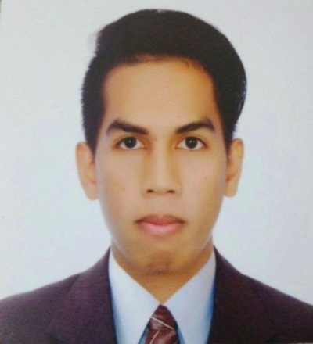
Jean
Jean.373231@2freemail.com
Objective
To use my skills in the best possible way for achieving the company’s goals and to keep up with the cutting edge of technologies.

Education

Tertiary Laguna State Polytechnic University
Sta. Cruz, Laguna
Bachelor of Science in Electronics Engineering
SY: 2010 – 2017
Secondary Kabulusan National High School
Brgy. Kabulusan Pakil Laguna
SY: 2006-2010

Primary Star of Hope Christian School
Taytay, Rizal
SY: 2000-2006

Technical Skills
1. AutoCAD application and diagramming.
2. Proficient and highly capable in MS Office application.
3. Knowledgeable in MS Excel, MS Power Point, and MS Word.
4. Proficient in basic electronics and schematic diagrams.
5. Strong communication skills both verbal and written.
6. BOQ (Billing of quantities) / BOM (Billing of materials)
Work Experience
- 7 months Intern at Philippine Long Distance Company (Telecom company)
- 3 months AutoCAD Operator at ENERTEL Inc.
- Maintain documentations of system installation and maintenance procedures.
- Performs system testing to evaluate performance and functionality.
- Performs regular inspections to identify defects and replacements.
- Creates technical drawings and plans for building and manufacturing by using computer-aided design and drafting
- Install and assemble of electronic system based on technical specifications.
- Repair and maintain electronic systems as needed.
- Maintain inventory control of electronic components and tools.
Coordinate with management to determine deadlines for the assigned tasks.
- 1 yr AutoCAD Designer in Thesis prototype
Personal Information
- Civil Status : Single
- Citizenship : Filipino
- Sex : Male
- Date of Birth : April 3, 1994
- Age : 23
- Place of Birth : Sta. Cruz, Laguna
- Religion : Roman Catholic
- Height : 5’8.5’’
- Weight : 64 Kgs
- Languages : English and Tagalog (Filipino)

“I am very excited to learn more about this opportunity and share how I will be a great fit for your company. Thank you for your time and consideration.”

