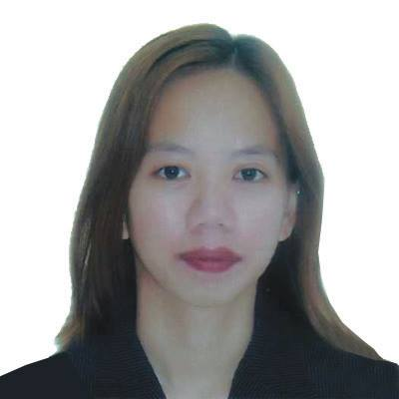
JACQUELYN
Jacquelyn.373316@2freemail.com

OBJECTIVES: To work in a highly reputable organization that will provide a different working experience, International cultural job exposure that enables me to develop my skills to become globally competitive and to contribute significantly towards the company’s growth in attainment of its mission and vision.
QUALIFICATIONS:
- Ability to work in diverse team and to communicate well with others.
- Dedicated and hardworking individual.
- Versatile, Honest and Responsible

SKILLS:
- Oriented in Microsoft office, word, excel, and power point.
- Good in Interpersonal skills.
- Good in oral and communication skills.

JOB EXPERINCES:
Lala Land Amusement Arcade
Uptown Mirdif Dubai
RECEPTIONIST
DUTIES AND RESPONSIBILITIES:(assisting customers, answering phone calls, sending and replying to emails, handling cash, sending quotation, filing of company documents, encoding invoices, printing and scanning)

WIPRO BPS
Gagfa Tower PanagdaitMabolo Cebu City Philippines
TICKET RESERVATION/CALL CENTER AGENT (2016-2017)
DUTIES AND RESPONSIBILITIES:taking inbound and outbound calls, answering inquiries, booking ticket, handling complaints

QUALFON PHILIPPINES
Asiatown IT Park Lahug Cebu City
CHAT SUPPORT AGENT (2015-2016)
DUTIES AND RESPONSIBILITIES:Sales account, selling telecom products, replying to inquiries, handling customer’s concerns.

N&DL DAIWA LOCKS
KaishiYamanashiken Japan
ASSEMBLER/MACHINE OPERATOR
DUTIES AND RESPONSIBILITIES:Production works, making locks and keys

XEROX COMPANY PHILS.
Asiatown IT Park Lahug Cebu City
DATA ENTRY OPERATOR (2008-2011)
DUTIES AND RESPONSIBILITIES:Medical Account, encoding patient and insurance information

PERSONAL INFORMATION: I am currently residing in Rashidiya Dubai, UAE. I’m Single with one daughter, born in Cebu City, Philippines on September 30, 1989.

EDUCATIONAL BACKGROUND:
ST. PAUL COLLEGE FOUNDATION, INC.
Computer Secretarial
(2006-2008)
VOCATIONAL EDUCATION:
Food and Beverages Services NC11
University of Southern Philippines Foundation

CHARACTER REFERENCES:Available upon request

I hereby certify that the above information are true and correct to the best of my knowledge and beliefs.

Applicant Signature

