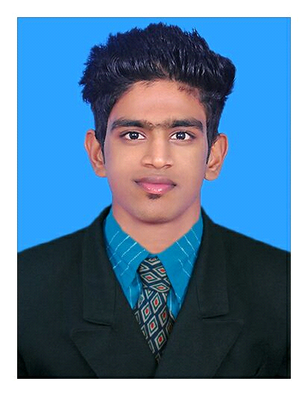
USAMATH
Email: USAMATH.373343@2freemail.com
Personal Data:-
Date of Birth : 12th Jan1995 Nationality : Indian
Religion : Islam
Visa Status : Visit Visa
Languages
English : Fluent
Hindi : Average
Arabic : Average
Malayalam : Fluent
Tamil : Fluent

Competencies
- Leadership Skills
- Communication/interpersonal skills
- Client relations
- Team leader
- Cultural understanding
- Flexible and quick learner
- Honest and dependable

CURRICULUM VITAE

CAREER OBJECTIVE

I cherish a demanding position that makes the effective use of my background. I would like to work in an environment where performance is rewarded with new responsibilities and where mobility is accepted norm.
ACADAMIC PROFILE
- BE mechanical engineering from Anna university Chennai
- Higher secondary [plus two] -board of higher secondary education Kerala.
- SSLC [State board of secondary education ,Government of Kerala ]

WORK EXPERIENCE
- MEP AND AUTOCAD TRAINING AT CADDCENTRE OTTAPPALAM
OCTOBER 2016-APRIL 2017
- INTERNSHIP IN COCHIN SHPYARD LTD[03-03-2016 to 11-03-2016]

RESPONSIBILITIES

- Developing, testing and evaluating theoretical designs.
- Discussing and solving complex problems with
Manufacturing departments, sub-contractors, suppliers and
Customers.
- Making sure a product can be made reliably and will
Perform consistently in specified operating environments;
- Managing projects using engineering principles and
Techniques
- Planning and designing new production processes
- Producing details of specifications and outline designs

- Recommending modifications following prototype test
Results.
- Considering the implications of issues such as cost, safety
And time constraints.
- Working with other professionals, within and outside the
Engineering sector.
- Monitoring and commissioning plant and systems.

TECHNICAL SKILLS
- AUTO CAD
- MEP (Revit) Design Software.
- Pro E-CREO 2.0{Design software}
- CATIA 3D CAD DESIGN SOFTWARE
- ANSYS SOFTWARE
CAREER SNAPSHOTES

- Carried out mini project on “HAND OPERATED MULTIPURPOSE MACHINE USING SCOTCH YOKE MECHANISM”

- Carried out main project on "FABRICATION OF HUSK REMOVER AND SHELL CUTTER"

DECLARATION
I, hereby declare that the above mentioned statements are true to the best of my knowledge and belief.

