RESUME 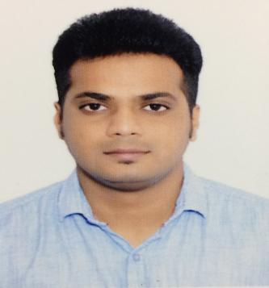
AKASH
E-mail: akash.373352@2freemail.com
VISA STATUS - VISIT VISA
Objectives
Seeking a challenging position as a Professional to deliver and to utilize my skills abilities. To develop evergreen solutions to personnel problems and strive to keep organization at the apex of professional excellence.
Personal Skills
Hardworking, Ability to deal with people diplomatically, Willingness to learn than earn more and quick learner.
Educational Qualification
- Master of Business Administration (MBA) HR & Marketing
- St. George College of Management & Science. (2011-2013)Bangalore University.
- (Aggregate: 64.5%)
- Bangalore.

- Bachelor of Computer Application (BCA)
- Sree Vidyanikethan Degree College. (2008-2011)
- (Aggregate: 62.2%)

Professional Experience
Ionidea Software Solutions (2015 March – 2017 May)
Designation - US IT Recruiter
Ionidea is an Information Technology consulting organization, based out of Fairfax, VA. The company has development centers in Fairfax, VA USA & Bangalore, India.
My Roles in Ionidea Software Solutions
- Build up the relationship with vendors in US staffing and consultants.
- Major responsibility was to work on the requirements.
- Was working closely with the Account Managers.
- Sourcing resumes from major job board’s like Monster USA, Carrier Builder USA, Dice and Ladders.
- Negotiate rates and closing candidates for submissions.
- Worked in close co-ordination with Sales and Recruitment Team, screen the candidates, work on the requirements.
- Expertise in recruiting US Citizens, EADs, Green Card Holders and H1B consultants.
- Experience working with Tax Terms like 1099, C2C and W2.
- Had a great experience working with major clients like Amazon USA, CDI Corp and Seven Step RPO.
My Roles in iPRIMED Educations (2014 – 2015) Capgemini
Designation - IT Recruiter
- Coordinating with the Team & Distributing Data to the team from Naukri Portal.
- Taking 1st round of interview i.e. Face to Face Communication check, for the candidates who have applied for the job.
- Pulling out the scores of the candidates who have given their Aptitude round.
- Briefing about the job and its Rules & Regulations to the selected candidates during the time of Capgemini Training.
- Documentation i.e. collection of Certificates from the candidates.
- Coordinating with College placement officer regarding the placements.
- Traveling to the Colleges in Karnataka & Andra Pradesh for the recruitment process for Capgemini Company.

Experience
- Worked in Mahindra Automobiles as sales executive in Sales stream for high end team XUV500& SsangYong Rexton SUV’S for 6 months. (2013 August – 2014 January)
Achievements
- Done with many College campus Interviews for the placements in Capgemini Bangalore.
- Convinced many candidates to work in night shift for Capgemini Company.
- Being representative for all my college functions and carried out successfully.
- District level player in Basketball player.
- Participated in car races.
Personal traits
- Quick Adaptability
- Self-Motivated
- Good Interpersonal Skills
- Workaholic
Declaration
I hereby declare that the above information furnished in my curriculum vitae is true to the best of my knowledge.
Personal Profile:
DOB: 29-10-1990
Sex: Male
Marital Status: Single
Yours Sincerely,
Akash.

