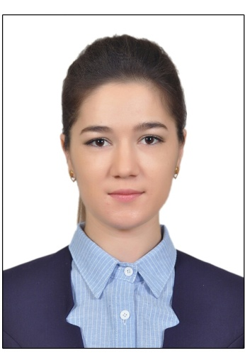
Feruza
Marketing/ Customer service/ Beauty advisor
Email: feruza.373357@2freemail.com | Citizenship: Uzbekistan

Objectives: Searching for a role with reputable company that requires extensive experience and knowledge of the marketing and beauty industry in addition to excellent customer service skills.

 | Education
Bachelors of Russian Language & Literature  Russian Philology, Tashkent State Pedagogical University  Tashkent, Uzbekistan  2012 - 2016 | Diploma: Specialist in Office Equipment’s  Academic Lyceum #2  under Engineering Pedagogical Institute, Namangan, Uzbekistan  2009 – 2012 | Certificate: High School  Mirzo Ulug’bek #9  Namangan, Uzbekistan  2000-2009
 | Experience
Russian teacher at secondary school №80 Tashkent city, Uzbekistan 09.2015 – 03.2017
Teach Russian language and Literature to 5th - 9th grades,
Advice co-curricular clubs and activities
Participate in on-going planning development and evaluation of curriculum
Effectively work with all children and parents

Manager, Global cosmetic company “Oriflame” Tashkent city, Uzbekistan 07.2010 – 12.2012
Attended beauty and cosmetic seminars improving product knowledge to consult with customers
Created and managed monthly events to generate business
Individually recognized for outstanding performances in achieving departmental & personal goals.
Kept over 100 personal clientele 50 business consultants, worked with many beauty salons
Planning development and management of sales personal and product marketing

Consultant, Global cosmetic company “Oriflame” Namangan 01.2009 – 07.2010
Listening to customers request, understanding their beauty needs & providing beauty treatments
Instructed clients on how to apply make-up to achieve a desired look
Assessing skin type of customers and applying best suitable cosmetics for beauty treatment
Educate clients on skin care procedures and products
Participate in planning special events and promotions
Languages:
Uzbek – native
Russian – fluent
English – upper-intermediate
Farsi (Persian)- intermediate

Computer skills:
Ms Office: Word, Excel, PowerPoint, Outlook, Windows Movie Maker and other social media applications.

