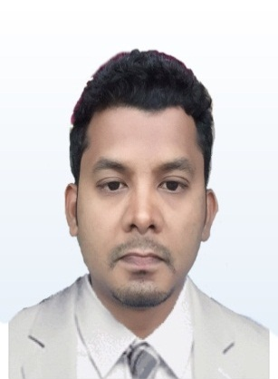
PERSONAL SUMMARY

VIJAY

email : vijay.373380@2freemail.com

HIGHLIGHTS

- Food preparation

- Planning menus

- Cost control

- Catering

- Hospitality

- Food for special occasions and events

AREA OF EXPERTISE

- Continental Cuisine

- Oriental Cuisine

- Teppanyaki Cuisine

Self-motivated professional with more than ten years of experience supporting kitchen operations. Quality-focused and efficient Sous Chef
adept at preparing and plating food in high energy fast-paced kitchens. Seeking to bring strong supervisory food prep and organizational skills in collaboration with a leading chef in the culinary world.

PROFESSIONAL QUALIFICATION

Khemeer café Abu Dhabi, UAE.
Chef April 2014 - present
Responsible got creating a good working atmosphere, coordinate and motivate the kitchen staff. Making sure all procedures involved in the kitchen are in accordance with Health and Food Safety standards.
Tangy Ocean Front Resort, Chennai, India
Sous chef 2011 – 2013
Zara Tapas Bar, Oriental Cuisine Pvt Ltd. Chennai, India
Chef De Parties 2007 - 2011
Zyng Asian grill, General star Kitchen Chennai, India
Commis I 2006 - 2007

Hotel Hemela, Karur, TamilNadu, India

Commis II 2005 – 2006

KEY SKILLS AND COMPETENCIES

- Able to cook a variety of different dishes including English and
Foreign dishes.
- An awareness of all health and hygiene requirements.
- Experience of restaurant / pub / inn style food production
- A good track record of achieving and consistently maintaining
target Gross Profit percentages.

TRAINING PERIOD

March 2004 July 2004

Organization - Best Western Germanus, Madurai. India

ACADEMIC CREDENTIAL

SSP Institute of Hotel Management and Catering Technology 2002 - 2004
Tiruchirappalli, Tamilnadu, India.

Diploma Hotel Management and Catering Technology – 80%

Tamilnadu State Board (High school) 2001 -2002

S.S.L.C – 70%

PERSONAL DETAILS
D.O.B : 10.06.1988

Gender : Male

Marital Status : Married

Nationality : Indian

Languages : Tamil, English, Hindi,Malayalam

DECLARATION
I hereby declare that all the above furnished particulars are true to the best of my knowledge and belief.

