AMEER (Member of SOE, Dubai Municipality Qualified Engineer)
Construction Management Executive with a track record of offering top performing solutions for construction projects and leveraging standalone expertise in making timely decisions that positively impact project success
ameer.373388@2freemail.com

Core Competencies  Construction Management  Site Operations  Project Management  Strategy Planning  Techno-commercial Operations  Systems Implementation  Quality Management  Liaison & Coordination  Team Management | Profile Summary
- Offering 12 years of comprehensive experience in the execution of numerous construction projects based and driving initiatives with respect to cost, resource deployment, time over-runs and quality compliance
- Multi-disciplinary exposure in executing diverse range of Construction Projects including Residential, Commercial, Institutional, High Rise Buildings and Infrastructure Projects
- Skilled in identifying areas in need of improvement with the vision to develop / implement successful action plans and schedules; as a result streamlined various initiatives and elevated company standards
- Proficiency in applying QA / QC & HSE norms in construction processes; skilled in streamlining systems to enhance operational effectiveness and meet operational goals within the cost, time and quality parameters
- Establishing and facilitating the centralized Project Governance / Compliance; analysing the overall effectiveness of project management across the organization and identify and mitigate areas of risk
- Excellent relationship management, analytical and negotiation skills; skills in swiftly ramping projects in coordination with engineers at site, clients, consultants, sub-contractors and statutory authorities

Education
- BE (Civil) from Zakir Husain College of Engineering and Technology, Aligarh, (Aligarh Muslim University) with 75.40% in 2009
- Diploma in Civil Engineering from University Polytechnic, Aligarh (Aligarh Muslim University) with 73.20% in 2004
Career Timeline (Recent 4 organizations)
Aug’14 – Dec’15
CBM Engineers, Gurgaon, India as Project Execution Manager
Aug’09 – Sep’10
Parsvnath Developers Limited New Delhi as Project Engineer
Jan’16 – till date
Simplex Infrastructures Limited, Dubai Branch, UAE as Manager Construction
Oct’10-Jun’14
Avana Integrated Systems Ltd. Abu Dhabi, UAE as Assistant Manager

Soft Skills

Communicator
Planner
Motivator
Collaborator
Change Agent

Work Experience

Jan’16 – till date Simplex Infrastructures Limited, Dubai Branch, UAE as Manager Construction

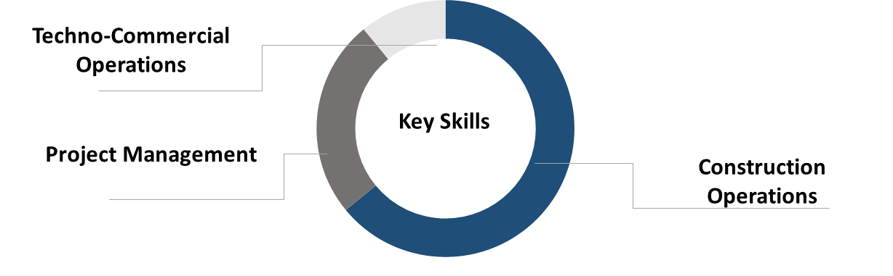
Key Result Areas:
- Steering the successful rollout of project operations
- Authority Coordination with Dubai Municipality, Dewa, RTA, etc for all projects in Dubai
- Tracking project activities with the emphasis on quality, drawings, specifications, standards & codes
- Developing & monitoring master schedules and weekly / monthly progress reports including earned value, milestones, BOQ, techno-commercial bids, cash flow & budgets
- Spearheading a sequence of construction activities involving assessment of material requirement, procurement cost-effectively, inviting quotations and analysis of rates, timely stacking / storing raw materials
- Preparing site execution plans and strategizing resources accordingly
- Providing reports on daily/weekly progress of site activities to PM and attending site progress meetings
- Liaising with clients, architects, MEP consultants, PMC, contractors, sub-contractors & external agencies for determining technical specifications, approvals and obtaining statutory clearances
- Preparing, checking & verifying the quality reports, performing quality checks (field inspection & tests) and confirming the non-conformance issues to superiors with likely solutions for acceptance
- Ascertaining compliance to safety, economical and technical assessments to secure the best economical results

Highlights:
- Effective cost control for the project by implementing earned value management and back charge to the subcontractors.
- Effective time control by controlling changes, delay in authority approvals and design co-ordinations.

Aug’14 – Oct’15 CBM Engineers (Engineering Consultant), Gurgaon, India as Execution Manager

Key Result Areas:
- Ensured effective coordination with Structural HQ, Design Director, Contractor, PMC and clients
- Performed timely inspection of structural works entailing Rebar work, QC testing’s, Formwork / Scaffolding & material submittals
- Generated reports on daily/weekly progress on site activities and attended site progress meetings, technical queries, RFIs, ATPs and ensured the closing of non-conformity reports (NCR)

Highlight:
- Coordinated for DLF Camellias Super Luxury High Rise Towers with a value 1 Billion AED; acted as a Standalone Lead Resident Engineer for Structural Designer
- Attended over 1000 RFI on-site and coordinated with design team-CBM, MEP designer and architects
- Ensured nil time delays of GFCs, clarifications, approvals and reworks due to misconceptions of drawings and specifications

Oct’10-Jun’14 Avana Integrated Systems Limited (Engineering & PMC), Abu Dhabi, UAE as Assistant Manager
Deputation:
Oct’10-Jun’14 ATS Group Ltd. Gmbh
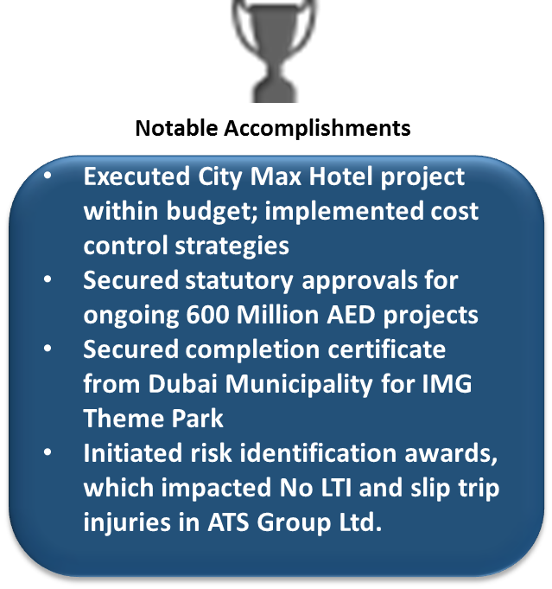
Key Result Areas:
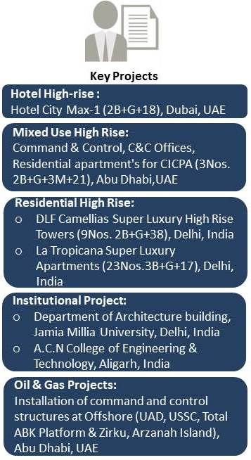
- Monitored the execution of construction activities as per specific plans; ensured the completion of work scope in accordance with the contract, budget, quality, HSE & security specifications
- Liaised with architects for drawings, consultant & third party contractors to ensure all equipment’s are fit for purpose
- Ensured adherence to company policy & Company Management System (CMS)

Key Projects:
- Construction of Mixed use High-rise buildings
- Fabrication & installation of command and control structures.

Previous Experience

Aug’09 – Sep’10 Parsvnath Developers Limited New Delhi as Project Engineer

Highlight:
- Headed onsite project management functions for La Tropicana Super Luxury Apartments

Sep’05-Jul’09 Emaraat Infrabuild Pvt. Ltd., Aligarh as Sr. Site Engineer

Jun’04-Jul’05 Friends Construction Co., New Delhi as Site Engineer

Certifications

- Gulf Technical & Safety Training (GTSC) Certificate
- ZADCO HSE Induction, ADMA HSE Induction
- H2S Escape Training from ZADCO & ADCO
- Permit to work (PTW) Certificate (Level-2)
- Electrical Safety training C18510 by TOTAL Exploration & Production, France
- Bosiet & Falck offshore training certificate (OPITO)

Trainings

- AutoCAD2002
- Primavera P-6
- MS Project
- 40 PMP Contact Hours

IT Skills

- AutoCAD, MS Office (Word, Excel & Power Point), Primavera P-6, MS Project & Internet Applications

Personal Details
Date of Birth: 16th February 1986
Languages Known: English, Hindi and Urdu
Nationality: Indian
Marital Status: Married
Number of Dependents: 2
Driving License: Light Motor Vehicle-Four Wheeler, UAE

