**Mazin**

[**Mazin.373400@2freemail.com**](mailto:Mazin.373400@2freemail.com)

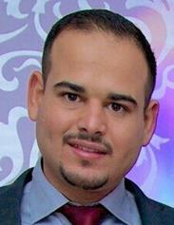

**Birth Date:** 1 January 1989

**Citizenship:** Swedish

**Driver’s license:** AM/BEuropean categorization

Solar Energy Engineer with a

Master’s degree in Solar Energy Engineering and a

Bachelor’s degree in Electrical Engineering. More than four years work experience with renewable energy in the Middle East and California. Excellent technical knowledge in solar systems and great experience in project designing, implementation and marketing in addition to first-rate computer skills.

**Electrical Engineer Specialized in Solar Energy**



**Employment History**

**Administrative Coordinator**

**November 2015- Present The Swedish Migration Agency, Uppsala Sweden**

* Retains administrative workflow by reviewing methods; applying cost reductions; developing reporting procedures
* Helping to resolve client inquiries
* Resolves administrative complications by analyzing data; identifying errors and implementing solutions
* Extensive computer and data associated errands
* Keeping the highest levels of customer service
* Identifying areas for potential learning and development
* Achieves department and organization mission by completing related results as required

**Solar Energy Engineer**

**May 2013- Aug 2014 Solaropia, San Diego, California**

* Designed and implemented detailed construction drawings
* Arranged and conducted customer site visits
* Corresponded with local and state regulatory authorities
* Provided technical support and consultation as needed

**Electrical Engineer**

**July 2010 - April 2013 Iraq Global Technologies, Baghdad, Iraq**

* Approving project specifications, budgets and timescales with clients and managers
* Testing, evaluating, and modifying products
* Arranged and conducted individual and group customer site visits as requested
* Using computer-aided design and engineering software to create project plans, case studies and circuit diagrams
* Team member responsible for designing, implementing, and managing one of the largest solar power projects in the Middle East to provide potable sterile water using 729 integrated factories powered by solar energy, distributed in 700 villages to supply pure water to more than 1 million people.

**Education**

**Sept 2014- Oct 2015 Dalarna University, Borlange, Sweden Master’s degree in Solar Energy Engineering**

**Thesis:** Modeling installation costs for rooftop PV systems, 30 ECTS,

Modeling the cost of installation for rooftop PV systems based on data collected for more than 700 projects. Dissertation work has done for Solkompaniet, which is the biggest company in Sweden in delivering turnkey photovoltaic systems.

**Sept 2006-June 2010 University Of Technology, Baghdad, Iraq Bachelor's degree in Electrical Engineering**





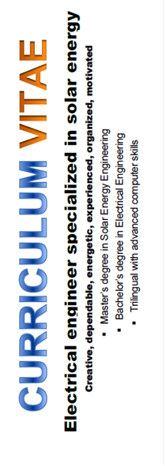

**Language skills**



**English:** Fluent **Arabic:** Native **Swedish:** Fluent

**Computer skills**

Microsoft Office, MS Word, MS Access, MS Excel, MS FrontPage, MS Project, MS Visio, Internet Explorer, Outlook, PowerPoint, AutoCAD Electrical, Visual Basic, Matlab, PV syst, Multisim, 3DS Max.



**Personality**

Creative, team worker, innovative, hard worker, competitive, fast learner, flexible, active and dynamic.

**Articles**

**03 April 2015 European Solar Engineering School, Master Thesis Samples, Modelling Installation Cost for Rooftop PV Systems**



**Publications**

**Modelling Installation Cost for Rooftop PV Systems, 2015 Dalarna University, School of Technology and Business Studies**

Independent thesis Advanced level, degree of Master, 30 ECTS



**References**

Will be provided upon request.