TAHER
Mobile: C/o 971501685421
E-Mail: taher.373421@2freemail.com

Senior Construction Project Management Professional
Qualified Civil Engineer with over 9 years of rich experience in Construction Management, Site Management, Project Management

Targeting managerial assignments in Project Management / Site Management with an organisation of repute

PROFILE SUMMARY

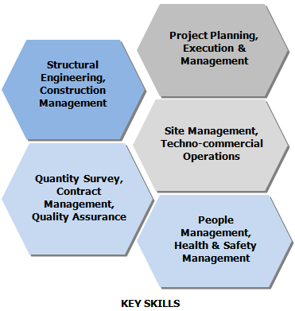
- Specialisation in construction of Infrastructure such as Commercial Buildings, Tower Foundation, Garden, Plant and son on
- Skilled in managing entire breadth of Project Management activities inclusive of planning, executing, monitoring, controlling, value engineering, capital expenditure management, waste reductions, cost control and safety
- Excellent track record of ensuring delivery of all projects and contracts on time, on budget & with high standards
- Proficient in managing the entire gamut of techno-commercial activities such as proposal & estimation, business development, enquiry generation, contract management & tendering and finalization of contracts with sub-contractors
- Expertise in ensuring quality at the project site by conducting quality tests and inspections
- Possess strong planning, analytical, communication, problem solving and people management skills

CORE COMPETENCIES
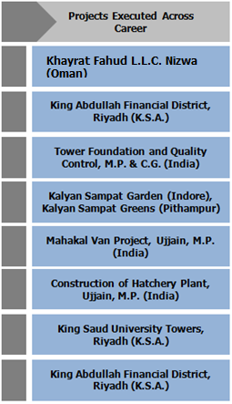
Project Planning & Execution
- Monitoring preparation of master schedules for projects including resource schedules, execution methodologies, budgets and cash flow projections; monitoring projects execution as per approved designs; evaluating project progress and developing reports
- Coordinating with multi-disciplinary project entities like local & national project authorities, client, architect, infrastructure designers, planners, structural designers, contractors & suppliers; developing & implementing Health & Safety Management plans and programs for all projects

Site & Construction Management / Resource Planning
- Overseeing the preparation of civil & structural shop drawings and design / contract drawings; obtaining approval from consultants; scheduled work as per master schedule & plan; monitoring & reporting on costs vis-à-vis budget
- Executing site work as per approved shop drawing; checking finished activities and conducting technical audits at site; verifying quality of material received at site

Contracts Administration & Management
- Managing various techno-commercial activities such as finalization of contractors, BOQ, Rate Analysis and so on; preparing technical & commercial proposals and executing tender negotiations
- Liaising with sub-contractors to ensure the interrelated activities for smooth progress of work; controlling the contract in terms of deviations at execution stage

QA/QC
- Ensuring quality at project site by exercising rigorous quality control plan & procedures
- Checking RCC and finished activities and conducting technical audits at site; verifying quality of material received at site

WORK EXPERIENCE

CAREER GRAPH
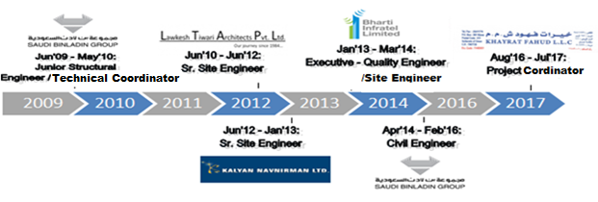
Aug’16 – July’ 17 working with Khayrat Fahud L.L.C., Nizwa (Oman) Joined as Site Engineer; Promoted as Project Coordinator in Jan’ 17

Project Executed:
Title: Construction of 20 Classrooms Boys School, 4 Star Hotel Nizwa, 2 Nos. of two storey’s villa
Location: Nizwa (Oman)
Client: Ministry of Education, Mr. Juma Ali Kimyani, Mr. Ali & Mr. Suleiman Kimyani
Project Value: 5.3 Million Omani Riyals
Role: Site Execution, Project Coordination between Client and Consultant, Leading a group of 3 engineers and 180 labors

Apr’14 – Feb’16 working with Saudi Bin Ladin Groups (RPD), Riyadh (KSA) as Civil Engineer; Promoted as Project Coordinator in Oct’14

Project Executed:
Title: King Abdullah Financial District
Location: Riyadh (K.S.A.)
Client: Riyadha Investment Company
Project Value: 313, 165, 350.00 Saudi Riyals
Role: Project Coordinator, Site Execution, Monitor Site Work as per the Contract, Reporting to Projects Director, Solving problems occur at site due to discrepancies of drawings, generate claims and variations against consultant or client due to the executed works as per client request and not in the scope of the contract.

Jan’13 – Mar’14 with Bharti Infratel Ltd., Indore, Madhya Pradesh, India as
Executive – Quality Engineer/Site Engineer

Project Executed:
Title: Tower Foundation and Quality Control
Location: M.P. & C.G. (India)
Clients: Idea, Reliance and Airtel
Role: Site Execution, Timely work accomplishments.

Accomplishments:
- Received Certificate of Appreciation from Bharti Infratel in year 2013 for working with accurate quality in works
- Acquired additional business worth INR 100,000 and secured new projects such as Idea & Airtel by delivering projects ahead of deadlines
- Pivotal in saving approx. INR 100,000 through innovative approaches such as timely finishing of projects, understanding site location and resolving some hurdles before execution (excavation and depth issues of the project)
- Played a key role in overcoming structural design, labours problems, deadlines of the project related challenges during the execution of projects

Jun’12 – Jan’13 with Kalyan Navnirman Ltd., Indore, Madhya Pradesh, India
Joined as Site Engineer; promoted as Sr. Site Engineer in Sep’13

Project Executed:
Title: Kalyan Sampat Garden (Indore), Kalyan Sampat Greens (Pithampur)
Client: KSG
Project Value: INR 55.66 Crores
Role: Site Execution, Project Management, Meeting Work Timelines, Completion of Site as per the Schedule, Timely Handing Over to the Client.

Jun’10 – Jun’12 with Lawkesh Tiwari Architects Pvt. Ltd., Indore, Madhya Pradesh, India as Sr. Site Engineer (Role: P.M.C)

Project Executed:
Title: Mahakal Van Project
Location: Ujjain, M.P. (India)
Client: Ujjain Municipal Corporation
Project Value: INR 24.83 Crores
Role: Site Execution with Quality, Coordinating between Client (Ujjain Municipal Coporation), Design Consultant & Contractor, Responsible for Work accomplishments as per the schedule.

Jun’09 – May’10 with Saudi Bin Ladin Groups of Construction, Jeddah City, Saudi Arabia
Joined as Junior Engineer; promoted as Assistant Technical Coordinator in Nov’09

Projects Executed:
Title: 1) King Saud University Towers
2) King Abdullah Financial District
Location: Riyadh (K.S.A.)
Client: Omrania Associates
Project Value: SAR 886,600,550
Role: Site Engineer, Coordination of Structural & Architectural Shop Drawings and Project Documentation, Solving the drawings related discrepancies.
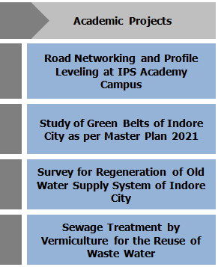
EDUCATION

- Bachelor of Engineering (Civil Engineering) from University of Indore, Madhya Pradesh, India in 2009
  - Attended National Seminar of Civil Engineers organised at Indore in 2005

INDUSTRIAL VISITS

- Omkareshwar Dam, Omkareshwar, Khandwa
- Jalud Water Treatment Plant, Indore
- Kabir Khedi Seewage Water Treatment Plant, Indore
- Choitram Hospital Waste Water Treatment Plant, Indore City, Madhya Pradesh
- Sardar Sarovar Dam, Vadodara City, Gujarat
- Sewage Treatment Plant, Vadodara, Gujarat

TRAININGS, SEMINARS, WORKSHOPS ATTENDED

- AutoCAD Civil 3D Workshop in association with Neon Infotech Pvt. Ltd. in year 2009
- 40th International Convention of IWWA in year 2008
- Career Mantra organized by Cerebral Heights at Indore location in year 2007

IT SKILLS

- AutoCAD and MS Office (Proficient)
- Staad Pro and SAP (Basic)

PERSONAL DETAILS

Date of Birth: 29th March 1987
Nationality: Indian
Marital Status: Married
Visa Status: Tourist Visa (Long Term)
Languages Known: English, Hindi, Guajarati and Arabic (Basic)

