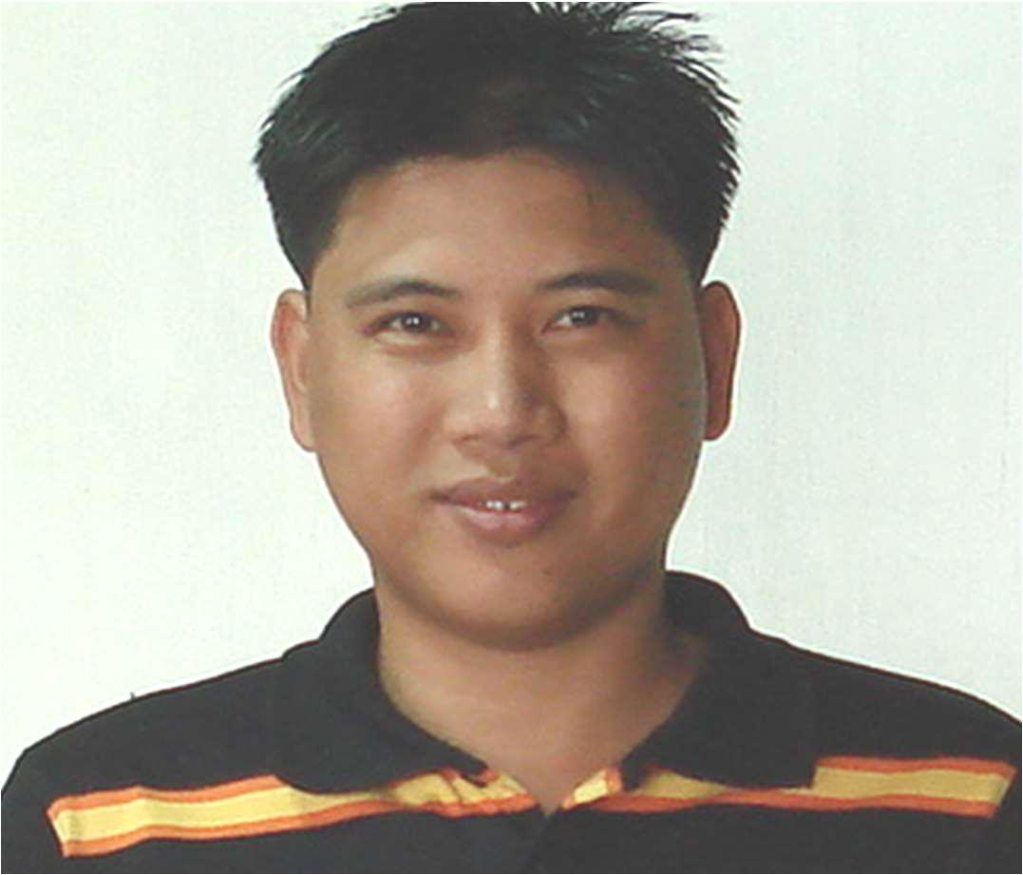

ALBERT JAYSON ASUNCION
QA/QC ENGINEER

PERSONAL STATEMENT

A resourceful Civil Engineer with vast experience in Civil Construction works. Strongly motivated in providing high quality service to the projects he works on, and is currently looking for employment in an open, friendly and professional environment where ideas are shared and opportunities seized.

KEY SKILLS
-Quality Assurance/Quality Control |  | -Estimation
-Site inspections |  | -Site Supervision
-HSE awareness |  | -Building Materials
-Technical support and consultation |  | -Site HSE & Quality Internal Auditor
PERSONAL DETAILS
Birth Date | : | March 4, 1977
Nationality | : | Filipino
Mobile No. | : | +974 66324007
E-mail | : | albert_asuncion04@yahoo.com

PROFESSIONAL SKILLS

Developing and prepare Project Quality Plan, Method Statements, Work Procedures, Inspection and Test Plan and Inspection Checklist as per Project requirements and Standards.

Prepare and submit Prequalification of proposed Sub-contractors/Suppliers.

Review Material Submittals, whether proposed materials complies with project requirements and current governing standards/specification.

Prepare technical queries for discrepancies encountered on site versus the approved shop drawings with proposed resolutions for Consultants approval.
Familiar with Quality Assurance and Control procedures in civil and architectural works.

Control of Quality documents like IR/MIR/NCR/QOR/RFI etc. to facilitate internal and external audits.

Project supervision/Quality Control of Schools, Commercial, Oil, Gas, Petrochemical and Water cooling plant, Medium Rise Buildings, Warehouses & Driving Schools civil works.

Well versed in operating AUTOCAD , Microsoft Excel & Word.

Able to read, interpret and prepare engineering plans & drawings using AutoCAD R2007. Project supervision for building construction (Pre-cast and Conventional).
Familiar with actual pre-cast and conventional construction works for steel and concrete civil

projects.

Update and maintain daily/weekly/monthly QA/QC Reports.

Capable to interpret construction progress schedules MS Project or PRIMAVERA Familiar with topographic survey works.

ACADEMIC QUALIFICATIONS

Bachelor of Science in Civil Engineering

Saint Mary’s University, Philippines

Licensed Civil Engineer Professional Regulation Commission,Philippines Registration No. : 0086591

CAREER HISTORY

QA/QC Engineer @ Imperial Trading & Contracting Company Doha, Qatar May 13, 2010 to Up to the Present
PROJECTS:

  - Birla Public School @ Abu Hamour, Qatar

- RASGAS- AKG-1 & AKG-2 Operator Shelters (SIH-61 & SIH-64 Extensions)

-H.E. Sh. Hamad Bin Jassim Bin Jabber Al-Thani New Villa Development & Majlis -Skeleton Works Constructions of Al-Rayan Palace & Majlis -Construction of New Six(6) Schools Package 6 Al-Wukair

-Proposed Construction and Development of Taxi Complex Driving School & Warehouses Duties & Responsibilities:

Prepare Prequalification & material submittals for Clients review and Approval based on projects Documents requirements and Specifications.

Prepare Method Statements /Work Procedures, Inspection and Test Plans for Consultants approval for Civil and Architectural Works prior to execution.

Conduct Daily Pre-Inspections on Site and verification prior to raising Inspection Notifications/Request.

Prepare Material Inspections of delivered materials on site.

Develop method statement for the activity including risk assessment and job safety environmental analysis and Inspection Test Plan and Checklist based on specifications of the project.

Carry out inspection and checking for all quality related procedures in the site and ensures activity at site are as per approved method statement.

Coordinate with the consultant’s representative and Site in-charge for inspection and meeting about quality problems including closure of Non-Compliance Report.
Report to the QA/QC Manager, control and monitor all activities related to Quality Management System, QMS.

Taking care of QA/QC documents of the entire project including certificates, calibration, test results, inspection requests, non-compliance reports and site instruction/observations, permanent materials delivered and other QA/QC documents. Responsible for closure of Non-conformance, NCR and Site Instruction, SI.
Responsible in the quality and workmanship of every activities, thorough knowledge of all phases of engineering construction relating to Civil, Architectural and Structural discipline interfacing the multidisciplinary operations.

Negotiating modifications with architects and consulting Engineer

QC Engineer @ SAMSUNG CORPORATION Yas Island, Abu Dhabi, United Arab Emirates August 07, 2008 to Sept. 1, 2009

PROJECTS:

  - Yas Island District Cooling Plant (DCP-08 & DCP-09)

Duties and Responsibilities

Engage in actual construction Inspection of Civil, structural to architectural works.

Make sure that works are being done according to Approved Shop Drawing and Project Specifications.

Prepare Daily Inspection Request/Material Inspection request

Civil Engineer -I/ QC Engineer @ AYTB (AL-YUSR TOWNSEND AND BOTTUM) Co. Ltd., Jubail, Kingdom of Saudi Arabia
May 20, 2006 to June 18, 2008

PROJECTS:

-United (JUPC) Glycol Transfer and Storage Expansion Project -AR-RAZI Plant V Methanol Expansion Project

-JUBAIL CHEVRON PETROCHEMICAL CO. Flare Relocation Project

-KEMYA Benzene Mitigation & Spent Caustic Deep Oxidation Unit Project, -Construction of AYTB Labor & Accommodation Buildings Project
Duties & Responsibilities:

Review of Project documents and AFC drawings and identify Scope of Works. Prepare Bill of Materials (Estimate) needed for the Project.
Prepare material approval for Clients review and Approval based on projects Documents requirements and Specifications.

Prepare ITP’s , Method Statements and Work Procedures for Civil Works prior to execution.

Prepare Bar Bending Schedule (BBS) required using AUTOCAD 2007. Actual supervision on site plant and Building Civil Works.

Prepare Request for information with proposals /resolutions on problems encountered during construction for clients approval.

Supervised the erection of Steel pipe rack structures located at King Fahad Port Royal Commission corridors and sabtank Areas.

Project / Site Engineer @ Property Company of Friends, Manila, Philippines March 29, 2004 to May 19, 2006
PROJECTS:

-Proposed 5-Storey Condominium & Office

-Dansalan Heights 4-Storey Condominium Buildings Duties and Responsibilities:

Engage in actual construction projects supervision. Inspections for Pre-casting of columns and beams.
Preparation of Bill of Materials as per Construction Stage requirements.

Erection supervisor by directing manpower on actual erections of beams and columns. Evaluate weekly billings of sub-contractors.

Review of contractor’s proposals for higher management review and approval. Monitor daily progress of the project.

Project Site Engineer /Estimator @ WR Trading and Services, Manila, Philippines. February 7, 2000 to April 17, 2004
PROJECTS:

-MEGAPACK MANUFACTURING Plant -Universal Robina Foods Factories -Housings & Residential Projects etc.

Duties and Responsibilities:

Engage in actual supervisions of Installation of Pre-painted Cladding & roof. Conduct actual measurements for proposed projects.

Prepare cost of Bill of Materials and Projects qoutations for bid purposes.

Prepare architectural details as per actual requirements for owner's approval.

I hereby certify that the above information and data are correct to the best of my knowledge.

ALBERT JAYSON ASUNCION

QA/QC ENGINEER

