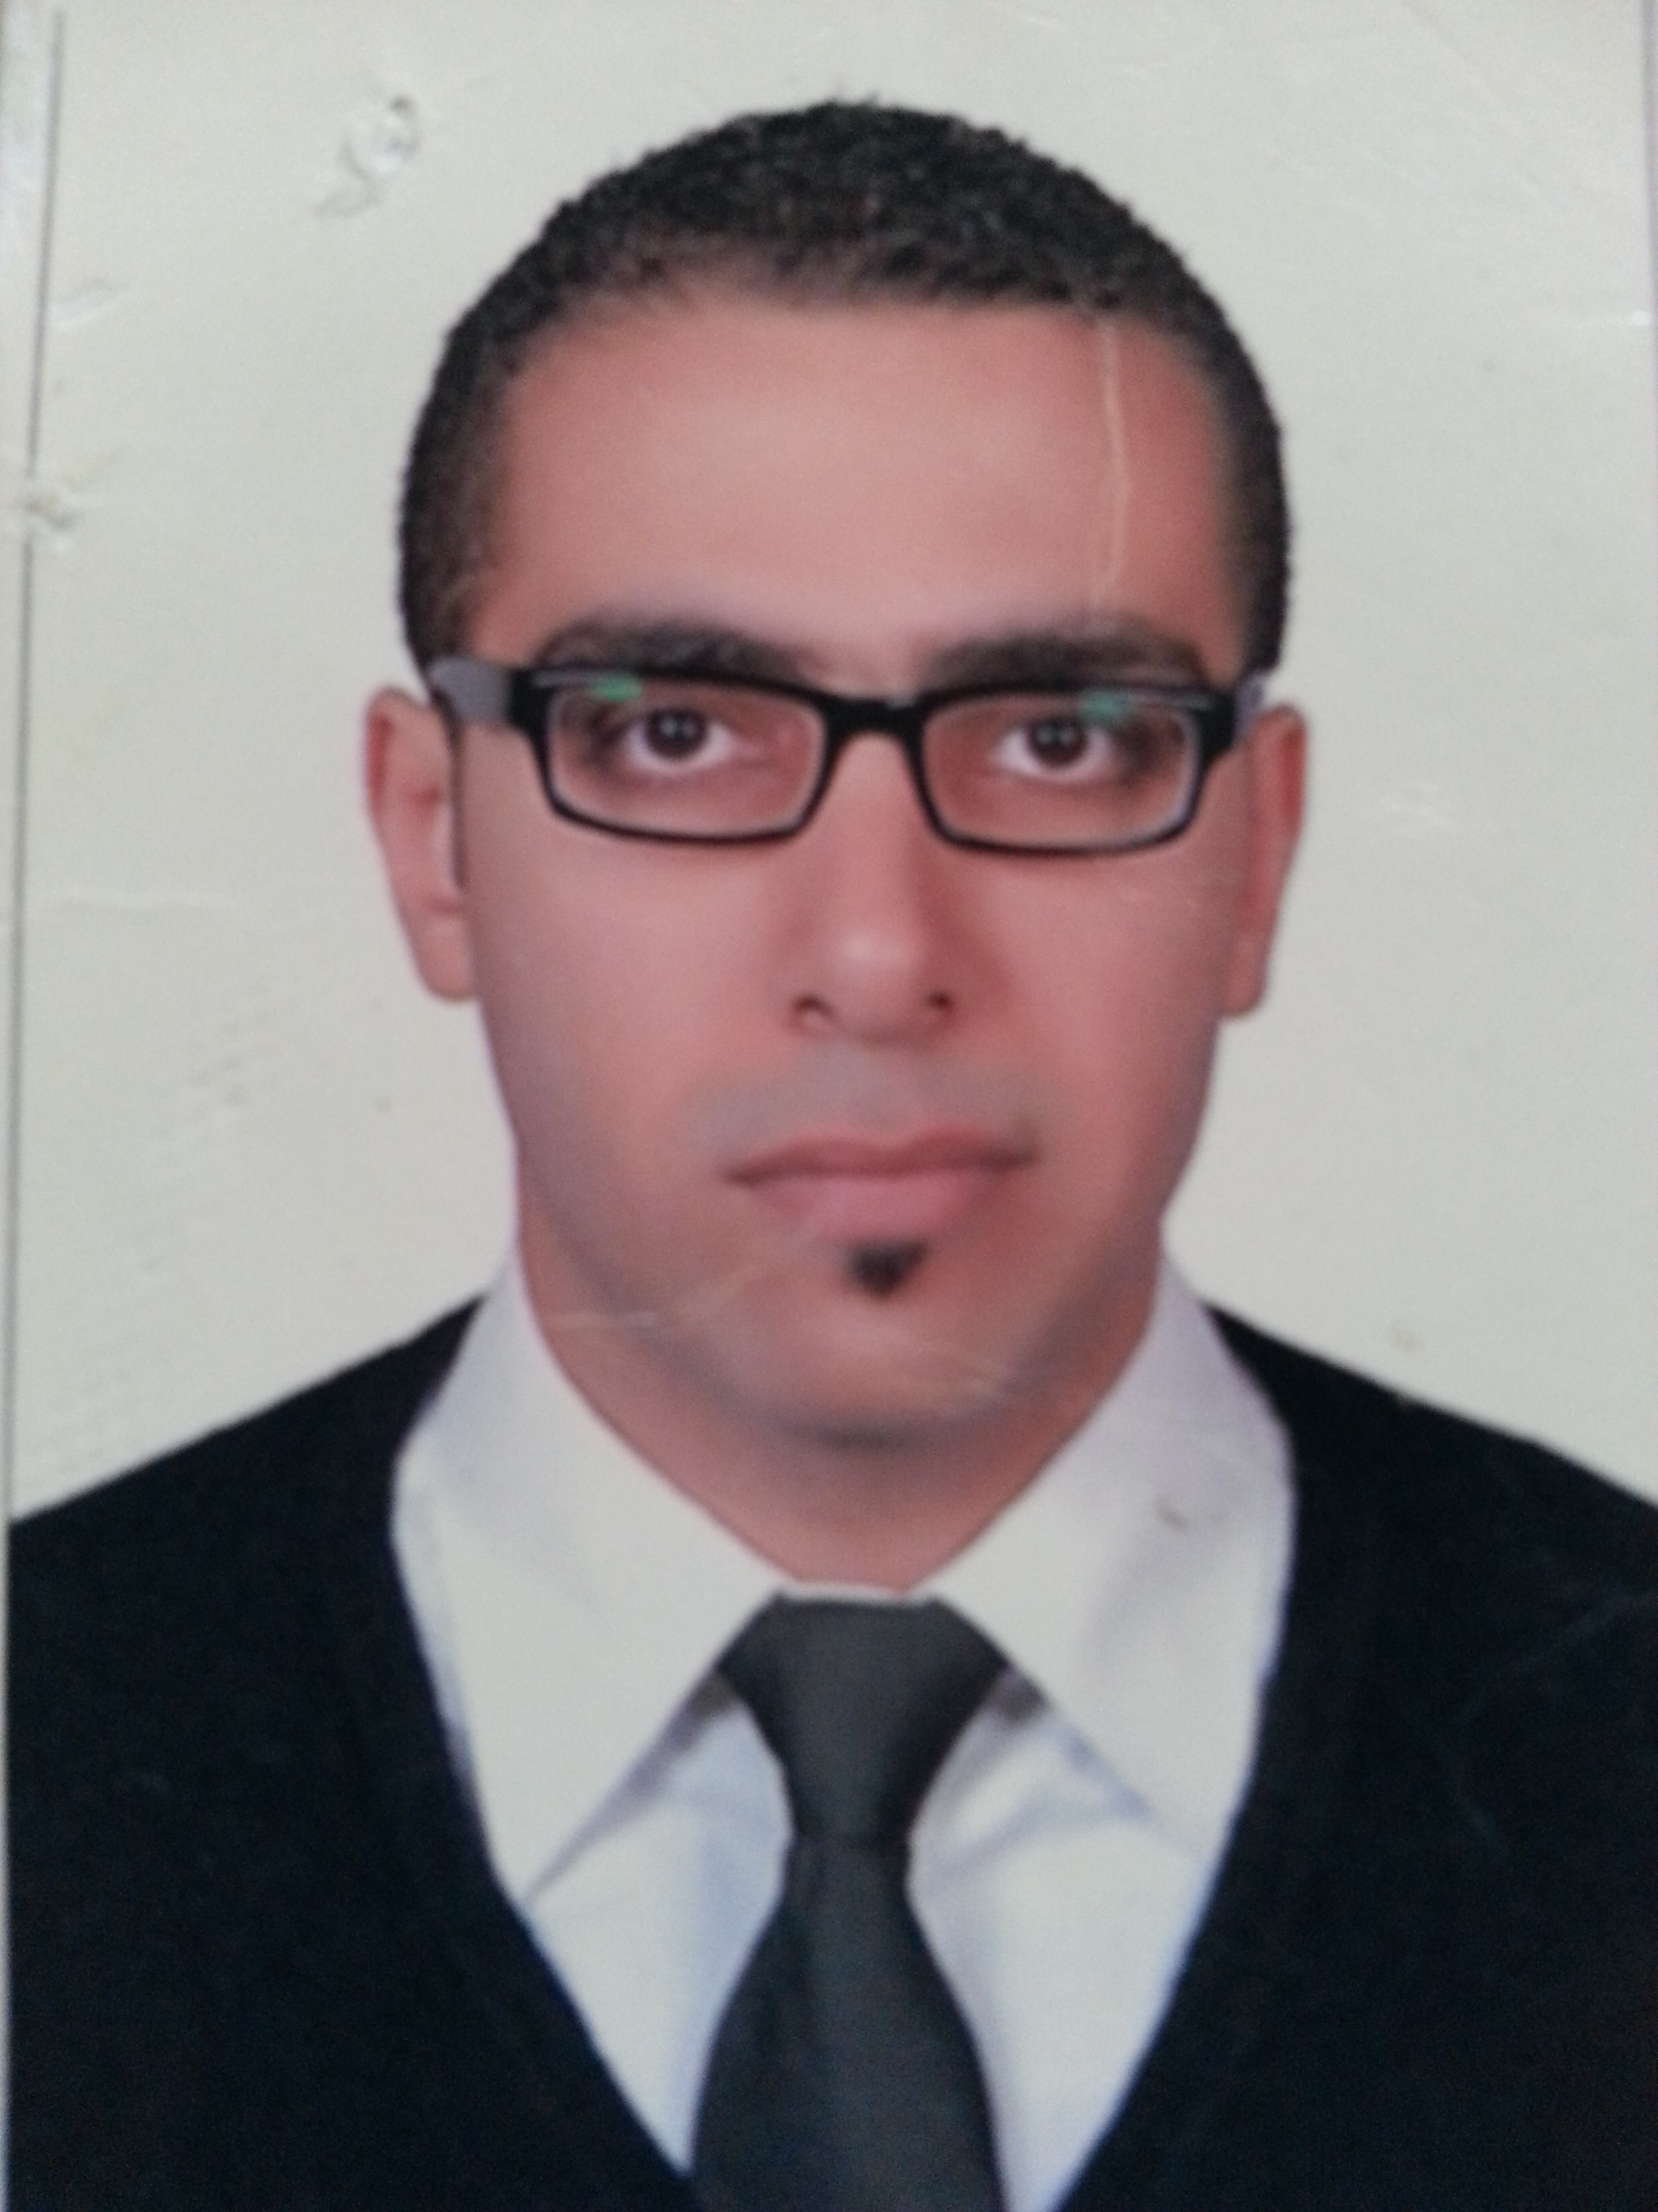

Ahmed

Ahmed.373437@2freemail.com

* Personal Data:
- Date of birth : 14th January 1986
- Nationality : Egyptian
- Military Status : Exempted
- Marital Status : Single

* Academic Qualification:
- B. Sc. in Veterinary Medicine, Cairo university (June 2009)

*Experience & career history:
- Veterinary Surgeon / Partner at “Pet’s Valley” small animal veterinary clinic (May 2015 till now).
Responsibilities
1) Clinical procedures:
*Examination, diagnosis and treatment of pet animals – including handling & restraining patients -
*Laboratory analysis.
*Diagnostic X-ray and sonography.
*Preventative procedures:
-Vaccination programs.
- Deworming programs.
- Control of external parasites.
*provide client education including nutritional and behavioral advice.
*Perform Euthanasia.

2) Surgical procedures:
# Surgery of the Skin
• Primary Wound Closure / Lumpectomy / Basic Flaps
# Abdominal Procedures
• Exploratory Laborotomy / Inguinal Hernia / Umbilical Hernia / Splenectomy / Abdominal Lymph Node
Removal and Biopsy
# Surgery of the Digestive System
* Biopsies / GDV / Gastrotomy / Incisional Gastropexy / Intestinal Foreign Bodies Removal / Intestinal
Resection and Anastomosis / Obstipation Surgical / Colopexy
# Surgery of the Reproductive Sys
* Ovariohysterectomy and Castration / Cryptorchidism (inguinal and abdominal) / Cesarean Section
(left flank and midline) / Pyometra / Episiotomy / Mamectomy (partial and complete)
# Surgery of the Urinary Tract
• Cystotomy / Cystostomy Tube Placement / Urethrostomy (scrotal, prescrotal and perineal)
# Perineal Procedures
*Anal Sacculectomy / Perineal Hernia / Rectal Prolapse / Tail Amputation
# Surgery of the Head and Neck
• Oronasal Fistulas / Cleft Palate / Eye Enucleation / Entropion, Ectropion, Entropion, Ectropion
Complex / Cherry Eye / 3rd Eye lid Flap / Ear Haematoma / Lateral Ear Canal Resection / Vertical Ear
Canal Resection / Brachycephalic Syndrome Surgery / Elongated Soft Palate
# Miscellaneous Procedures
* Declawing / Dewclaw Removal / Amputations (fore and hind limb) / Elbow Hygroma
# Dental Procedures
* Teeth Cleaning / Tooth Extraction
# pre and post operative care.

3) Traveling procedures:
*Health certificates, microchip and rabies titer testing for traveling animals.

4) Management responsibilities :
*Mentoring junior veterinarians and distribute tasks.
*Medical training of staff.
*system implementation and monitoring of effectiveness.

- Veterinary Surgeon at “Pet Vet” small animal veterinary clinic ( June 2011 till April 2015 )

* Skills:
- Computer skill :
- Windows Operating Systems (Excellent).
- Microsoft Office Pack.

● Language skill:
- English: Excellent command of both written and spoken.
- Arabic: Mother tongue.

References are available upon request.

