Career Objective
To work for a progressive organization in a highly motivating and challenging environment that provides the best Opportunities to grow and utilize my potential to the fullest to achieve the organization’s goal while achieving my personal goals.
Career History
MYND SOLUTIONS PVT LTD.
Associate executive (period 18st January 2017 to 7th September2017)
Duties:
- Calculating and checking to make sure payments, amounts and records are correct.
- Prepare daily journal entries and general ledger account reconciliations
- Invoice processing
- Purchase order checking and analyzing
- GST checking
- Vendor enquiry handling
- Daily PHD report making
- Performed posting of customer payments by recording cheque, cash and
Credit card transactions.
ACCOUNTANTS SERVICE SOCIETY
Accountant (period 4th April 2014 to 21st March 2016)
Duties:
- Responsible for maintaining daily expenses records and preparing daily
work schedules for smooth flow of work
- Prepare trading, profit and loss account
- Prepares asset, liability, and capital account entries by compiling and analyzing account information.
- Prepares special financial reports by collecting, analyzing, and summarizing account information and trends.
- Analyzing tax

Personal Competencies
- Committed and Dedicated
- Hardworking person
- A Good team player

CURRICULUM VITAE
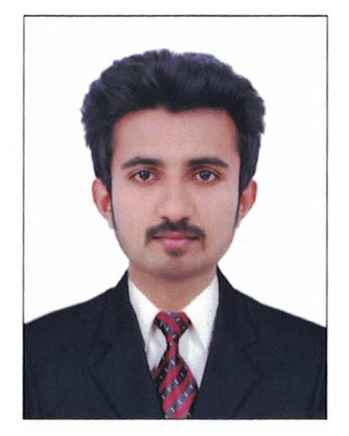

LIBIN

Personal details

Email: libin.373444@2freemail.com
State: Kerala
Nationality: Indian
Sex: Male
Date of birth: 24/09/1993
Marital Status: Single
Visa Status: Visit Visa

Language known
- English
- Hindi
- Malayalam

Educational Qualification
- Pursuing MBA specialized major in Human Resource from Bharathiar University.
- 2014 diploma in Corporate Accounts And Management from Accountants service society
- 2011 – 2014 B.com with computer application from Mahatma Gandhi University, Kottayam.
- 2013 Diploma in computer application from Nirmala College of Information Technology, Chalakudy.
- 2011 Plus Two (commerce) from St. Antony’s Higher Secondary School mala

Achievements

- Participated in the final stage of new product presentation conducted by Commerce Department Of Nirmala College Of Information Technology.

Computer Awareness
- Regular User of PC and Internet
- Windows 7,8,10
- Microsoft Applications (Word, Excel, Office, PowerPoint)
- Tally 9
- Oracle ERP
- SAP
- Outlook

LIBIN

