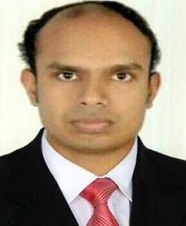

Renjith

Email: - renjith.373452@2freemail.com

Objective

To work in an organization where I use my skills and knowledge to deliver value added results as well as further enhance my learning and develop my carrier.
Work Experience

KERALA STATE CASHEW DEVELOPMENT CORPORATION (KSCDC)

POSITION: -ACCOUNTANT 2012 present
Responsibilities are as follows:
- Preparation of financial statement

- Preparation of payroll accounts

- Data entry work

- Accounts payable & accounts receivable

- Preparation of petty cash book

- Preparation of cash flow & fund flow statement

- Preparation of budget

- Bank reconciliation

- Knowledge in VAT

- Preparation of fixed assets & depreciation statement

- Knowledge in IFRS

K.S NAIR & CO, CHARTERED ACCOUNTANTS

POSITION: - ACCOUNTANT 2009-2012
Responsibilities are as below:
- Preparation of Financial statement

- Data entry work.

- Ledger scrutiny

- Preparation of income tax return

- Conducting company audit

- Conducting bank audit

- Preparing sales tax return

Computer Skills

- Well versed with MS Office.

- Well versed with TALLY, PEACHTREE, QUICK BOOKS
- Elementary knowledge in internet

- Updated with all the latest computer applications and software’s

Basic work attitude

- Highly motivated and dependable in achieving goals

- Confident in making independent decisions

- Competitive, efficient ,hard working and enthusiastic

Education

- Master degree in commerce

University of Kerala Trivandrum, Kerala
- Bachelor degree in commerce

University of Kerala Trivandrum, Kerala
Personality Traits

- Ability to work independently both with minimal supervision as well as in a team.

- Flexible and adaptive
- Good Communication Skills
- Effective and efficient in using time Management
Languages known

- English – Read, write & speak
- Hindi – Read, write
- Malayalam (mother tongue)
Personal information:

Nationality | : | Indian
Marital status | : | Bachelor
Age | : | 29
Visa status | : | Visit Visa

Declaration:

I sincerely state that the above mentioned facts are true to the best of my Knowledge and belief.

Renjith

