Zaid
Zaid.373463@2freemail.com

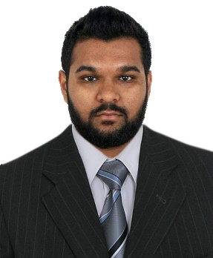

Objective | To obtain a full-time job that incorporates a hands-on experience in the field of Mechanical Engineering.

Education | ROCHESTER INSTITUTE OF TECHNOLOGY Graduated – May 2017  Dubai, U.A.E.  Bachelor of Science, Mechanical Engineering  THE INTERNATIONAL SCHOOL OF CHOUEIFAT Graduated – May 2012  Ruwais, Abu Dhabi, U.A.E.  High-School

Experience –  Work | ZETEON SOLUTIONS PVT. LTD., Bangalore, India May – August 2016 Trainee (Internship)  - Assisted the team in testing and documentation for the mechanical design of H2M and M2M interfaces.  - Learned and helped with python programming.  - Worked on other tasks assigned by the supervisor.  DESCON AUTOMATION CONTROL  SYSTEM LLC., Dubai, U.A.E. January – May 2016  Coop Trainee (Internship)  - Worked under the design and assembly team.  - Helped create mechanical design documents for parts and finished products.  - Understanding and testing finished products.  - Created a report of what was learnt during this internship  NASH ENGINEERING FZCO, Dubai, U.A.E. June – August 2015  Engineering Trainee (Internship)  - Worked under the Technical and Management System Manager and his team of engineers.  - Checked Material Test Certificate, Chemical compositions, Mechanical and Physical, Welding visual inspection before and after.  - Witnessed NDT techniques such as MPT, DPT, UT, and RT.  - Witnessed PMI, Hydrotest and Welding processes.

Labs and Courses | - Engineering Measurements Lab  Materials Science with Applications Lab  - Strength of Materials I Lab  Circuits I Lab  - Engineering Applications Lab
 | - Circuits I  - Dynamics  - Engineering Design Graphics  - Fluid Mechanics I  - Materials Processing  - Materials Science with Applications  - Measurements and Instrumentation Controls I  - Contemporary Issues – Bioengineering  - System Dynamics  - AC in Hot and Humid Environments | - Problem Solving with Computers  - Statics  - Strength of Materials I  - Thermodynamics I  - Thermodynamics II  - Strengths II  - Heat Transfer  - Renewable Energy Systems  - Numerical Methods

Computer  Skills | - MATLAB  - Creo Pro/E  - Microsoft Office  - ORCAD Capture  - AutoCAD | - Basic Arduino Programming Language  - Basic Python Programming Language  - Trimble SketchUp

Activities and Hobbies | - Built a Clap Pattern Recognition Switch using Arduino.  - Modified an RC Car to work with an Android Bluetooth device.  - Home automation projects, such as making Siri/Bixby to switch on my bedroom lights.  - Reuse of broken toys motors for creating usable stuff such as cars, fans, etc.

Languages | - English - Fluent  - Urdu - Native language  - Hindi - Intermediate  - Arabic - Intermediate  - French - Intermediate
Passport  and Other  Details | - Date of birth: 25/09/1994  - Nationality: Indian  - Marital Status: Single  - Driver’s License: Valid UAE driver’s license  - Nationality: Indian

