CURRICULUM VITAE
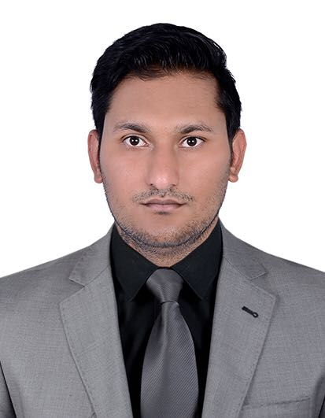

Gurpreet
Email: Gurpreet.373464@2freemail.com

OBJECTIVE

To effectively utilize my skills in a growing organization and contribute any ideas of value towards achieving organizational goals.

MAJOR STRENGTH
- Five years’ experience in leading organization in the region
- Excellent communication skills
- Hardworking and result-oriented
- Highly self-motivated, ambitious and dedicated in providing high standards of service
- Fast learner and self-motivated
WORK EXPERIENCES
COMPANY: ARKAN SECURITY MANAGEMENT SOLUTION
DURATION: MARCH 2012 to July 2017
- Zabeel Saray Hotel (Security Guard December 2011 to May 2012)
- The Dubai Mall (Emergency Respond Team May 2012 to October 2016)
- Dubai Creek & Harbour (Vehicle Patroller & Act Supervisor October 2016 to July 2017)
Responsibilities:
- Keeping records of temporary access cards ,keys, lost and found items
- Writing incident reports
- Dealing with customers
- Monitoring Access Control for any alarm and react accordingly
- Responding radio communication
- Maintaining Bed Down Reported and sending to higher management
- Directly reporting to security supervisor and higher management if any incident occurs during duty period.
- Keeping the record of daily duty activities
- Taking preventive measures to reduce the losses in the organization
- Attending Visitors and assisting them to the proper locations.
- Checking contractors during the non-trading hours access the mall with the proper work permit and dealt with the company policy.
- Patrolling inside the mall and unauthorized activity is reported immediately
- Adhere to company health and safety regulations.
- Ensure all accidents are reported.
- Report any misshapenness to the Management.
- Attending maintenance complaints and forwarding to the maintenance team.
Educational Qualification

  PUNJAB EDUCATION BOARD
Senior Secondary

  DEPARTMENT OF PROTECTIVE SYSTEM (DPS)
Conducted by Dubai Police on Dec. 2011

  FIRE SAFETY AWARENESS TRAINING
Conducted by TDM Emergency Rescue Unit
Personal Data
Date of Birth : 06/11/1989
Nationality : Indian
Marital Status : Single
Visa Status : Employment
UAE valid Driving License LMV : License valid until 19-08-2026
Languages known : English, Punjabi and Hindi
Hobbies : Swimming, Cricket and Travelling

Declaration

I DO HEREBY DECLARE THAT ALL THE INFORMATION GIVE IN THE RESUME ABOVE IS TRUE AND CORRECT TO THE BEST OF MY KNOWLEDGE AND BELIEF.

