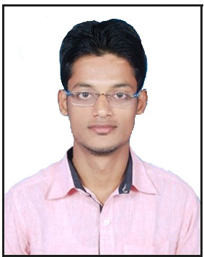
CURRRICULAM VITAE
HASHIMI.373469@2freemail.com

OBJECTIVE : To work as a Mechanical Engineer in your
Esteemed Organization.

NAME : HASHIMI

DESIGNATION : Mechanical Engineer

NATIONALITY : Indian

LANGUAGE : English, Hindi and Urdu

TECHANICAL
QUALIFICATION : Completed “B-tech” in Mechanical Engineering
On May 2016 with 65.86% from “Jawaharlal Nehru
Technological University” Kakinada (A.P)
ACADEMIC
QUALIFICATION : Complete 10th from BSEB, PATNA (Bihar) in the Year 2010 with 52 %.

: Complete 12th from BSEB, PATNA (Bihar) in
the Year 2012 with 62 %.

DESIGINING
PROFICIENCY : Two months Auto-Cad Designing
Course from Cad Centre Vijayawada, (A.P)

COMPUTER
PROFICIENCY : MS-office-Word, Excel & PowerPoint, windows

- PERSONAL STATEMENTS
My primary objective as a Mechanical Engineer is to contribute to the company’s success by ensuring that all phases of maintenance and repair operations are done effectively and with minimal hassles. In order to do this, I will see to it that health safety and quality standards are met and , I have honed my abilities is performing indispensable duties such as regular assessment of equipment system , I am confident that will be an asset to the company.

- TRAINING AND PROJECT WORK:-

1) 23th June to 21th July. 2015 : Industrial training in
“GARDEN REACH SHIPBUILDERS
AND ENGINEERS LTD” Kolkata
(West Bengal)

2) 10th Feb to 10th Apr.2016 : Project in LOCO-SHED (South
Central Railway) Vijayawada (A.P)
- EXPERIENCE:-

1 Year in “PRODUCTION AND MANUFACTURING IN INJECTION
MOULDING”
Destination- PRODUCTION SUPERVISIOR
Team size- 10
Working Period- SEPTEMBER 2016 TO SEPTEMBER 2017

- INTERPERSONAL SKILL:-
- Good Communication Skills.
- Ability to cope up with different situation.
- Confident and Determined.
- Hard Working, Teamwork Skills.
- Installation and Repair Machines.

- PERSONAL INFORMATION

Date of Birth : 20-02-1995
Place of Birth : GHAZIPUR
Marital Status : Single
Hobbies : Browsing Internet, Travelling, Singing, Playing
Cricket

DECLARATION:-
I consider myself familiar I hereby declare that the above- mentioned information is correct up to my knowledge and I bear the responsibility for the corrections of the above-mentioned particulars.

