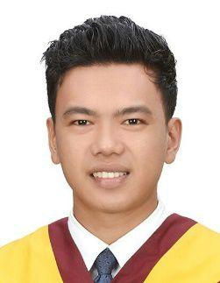
​ ​​Curriculum​Vitae
Sernie​​ Paul​
Email: serniepaul.373474@2freemail.com

Personal​Summary

An Electrical Engineering graduate with proven time-management and collaborative skills developed whilst studying. With the ability to work under pressure, flexible and more than willing to work longer hours and able to cope up with different challenges. Knowledgeable and keen with electrical safety understanding and some practical experience. Seeking opportunity to start a professional career with a long-term job in a reputable company. Easy-going person and can get along well with other colleague of different nationalities. Currently​on​a​visit​visa​and​willing​to​be​relocated​as​soon​as​possible.
Career​Objective

To secure both a challenging and rewarding position as Junior​ Electrical​ Engineer in​ a growth-oriented organization​where​I​can​demonstrate​and​contribute​my​professional​expertise​and​technical​skills.
Technical​Skill
- AutoCAD​Electrical​Lay-out​and​Design
- AutoCAD​MEP​(Mechanical,​Electrical​and​Plumbing)
- Advance​computer​knowledge
- Residential​Wiring
- Electrical​Design
- Ability​to​work​under​pressure
- Ability​to​handle​and​solve​problems

Previous​Employment
SJV​–​Trading​and​Construction Philippines
Electrical​Maintenance/Electrician ​​April​2016​–​May​2016

240​hours​on-the​job​training​with​guidance​on​maintenance​and​electrical​safety.

Responsibilities:
• Worked​closely​alongside​Senior​Engineers​with​very​less​supervision
• Worked​design​and​technical​reports
• Involved​in​computations​and​solving
• Assisted​in​making​lay-outs​and​blueprints
• Assisted​in​filing​and​sorting​of​documents​and​blueprints

Academic​Qualifications
Cebu​Institute​of​Technology​–​University Philippines
Bachelor​of​Science​in​Electrical​Engineering 2010​–​2016

Cataingan​National​High​School Philippines
Secondary​(Grade​7​to​10) 2006​–​2009

