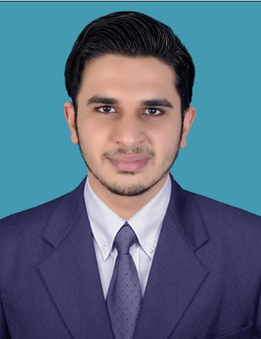
MOHAMMED
E-mail: MOHAMMED.373476@2freemail.com

OBJECTIVE
A challenging position in the business processes to provide an effective and efficient solution which would assist the organization to get the finest solution in the business and to increase productivity in the market.
PROFESSIONAL EXPERIENCE

ITL World Tours & Travels .India.
MG road, Kochi
Experience: - 2 YEAR (15TH Jun 2015 – 31st Jul 2017)
Travel Consultant Ticketing

EDUCATIONAL QUALIFICATION

- MBA (Master of Business Administration) : Barathiyar University (2016)
- IATA (travel & tourism) :Riya Aviation Academy (2016)
- B.B.M(bachelor of business management) : Bangalore University, INDIA (2014)
- Plus 2 : Kerala State Board (2011)
- 10th : CBSE (2009)

DUTIES AND RESPONSIBILITIES

Reservation & Ticketing – Galileo, Abacus & Amadeus
Respond to Mail Queries Dealing with Passengers, Corporate & Sub Agents.
Information Technology and Internet strategy. Managerial skills, Negotiation skills & Professional salesman ship. Loss Prevention & Cross- cultural Awareness.
General Sales Agent with Corporation &Tour industry. Tour package & Special interest tours.
Airport Environment & Airport Customer Service for Global Clientele.
Aviation Principals and Operations. Fare Quoting, Reservation and ticketing.
Handling with Various Airlines & Airline Ticketing.
Customer Interaction & Counter handling.

SKILL SUMMERY:

- Excellent customer service skill & computer skill
- Strong spoken and written communication skill
- Ability to work under pressure & handle difficult situations with diplomacy
- The ability to deal tactfully with upset or angry passengers
- Proficient in windows.
- Presentable personality, discipline and managed in the work culture and ready to accept work load and execute successfully to fulfil satisfaction of the employees.
- A good team player with positive attitude.

TECHNICAL SKILLS:
- Galileo, Abacus, Amadeus.
- Ms Word, Ms Excel, Ms Office
- Adobe Photoshop & Illustrator, etc

ACHIVEMENTS

- Have won award for leadership volunteer
- Participated in business related seminars
- Have won several prizes at school and college level competitions
- Selected as a college team captain

DECLARATION
I hereby declare that the above written particulars are true and correct to the best of my knowledge and belief.

