RESUME
MANU
MANU.373482@2freemail.com 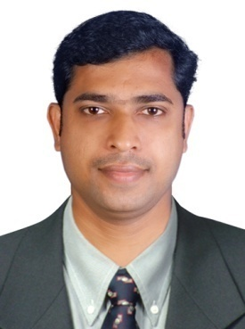
CAREER OBJECTIVE
To attain a challenging position in the customer service and hospitality department.To attain development of management skills an appication techniques to maximize contributing to the organization and get fuller meaning of job satisfaction.
WORK EXPERIENCE
Worked as a HEAD CASHIER in LUA LABANESE RESTURANT AND BAR IN DUBAI(2015-2016)
Worked as a CASHIER in O2 NIGHT CLUB DUBAI(2014-2015)
Worked as a BARISTA IN STARBUCKS COFFEE DUBAI(2012-2014)
Worked as a TEAM MEMBER IN KFC DUBAI(2009-2012)
STRENGTH
LEADER SHIP QUALITIES,COMMUNICATION SKILLS,HANDLE AND WORK UNDER PRESSURE,HONESTY ,ACCURACCY,FAST LEARNING
EDUCATIONAL QUALIFICATIONS
DIPLOMA IN HOTEL MANAGEMENT
PREE DEGREE
SSLC
PLACE OF ISSUE:DUBAI
PERSONAL DETAILS
SEX :MALE
NATIONALITY :INDIAN
DECLARATION
I hereby declare that the information furnished above is true to the best of my knowledge and belief
Place :Dubai

