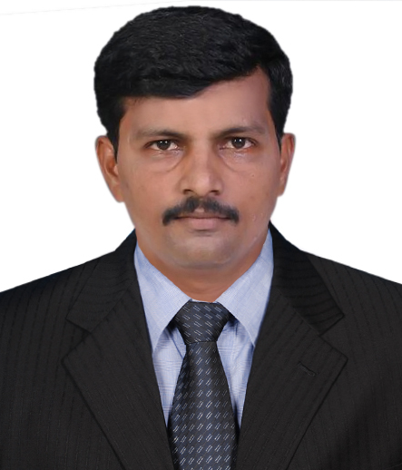
SUDHAKAR
SUDHAKAR.373492@2freemail.com
PARTS ENGINEER
With a successful & rewarding career of 18 years, seeking senior level assignments across the industry

PROFILE

- Competent, diligent & result-oriented Sales & Marketing Professional with an excellent & rewarding career of over16 years. Currently working in Unibeton ready mix DUBAI, UAE.
- Experience in the Channel Management, Sales & Marketing Management & Business Development while performing in the cost-efficient manner along with the unwavering quality standards.
- Have been successfully achieving 100% targets with excellence in performance.
- Possess keen business acumen in analyzing and understanding business requirements, customer-value maximization and developing new business processes and revenue streams.
- Visionary leadership in assessing client needs, and strategically positioning programs aligned with customer and market needs/ projections.
- Resourceful and competent to create win-win relationship with Corporate Client and Customers through excellent coordination/ negotiation skills for repeat/ referral business.
- Strong team leader builder and facilitator, fostering an atmosphere that motivates highly talented professionals to balance high-level skills with maximum productivity.

Key Competencies
Penetration Trainings Compliances Relationship Management Operations Management Channel/ Vendor Management Spare parts monitoring Strategic Management Target Achievement co-ordination.

PROFESSINONAL EXPERIENCE

UNIBETON READY MIX – DUBAI From: June2016 to Present.

Engineer –Spare parts ordering for country operations.
- Ensure that the spare parts receive and issue procedure followed by store team
- Do random check with invoice and physical
- Do random check on updation of system, bin location,
- Ensure full parts consumed before end of life
- Replacement ordering the qty and consumption of spare parts in coordination with the user, purchase and store department
- Review and investigate warranty concerns through communication and returned part review with suppliers and field quality center.
- Ensure ordering cycle for optimum conditions as per budget provisions
- Plan and monitor the stock levels for the fast moving spare parts assuring the continuous availability as per maintenance plan
- Provide technical information to purchase dept. for procuring.
- Ensure timely arrangements of the requirements carry out and scope of works
- Cover all related functions including communications coordination and documentation

- Interaction with other departments for spare parts concern
- Work with other engineering groups, Inventory center and vendor regarding sparepart information and conduct technical assessment.
- Excellent working knowledge and overall understanding about spare parts
- Ensure adherence to company HSE policy and guide lines
- Develop procedure in creating handling mainting and disposition of files

SRI RAJATHI AUTOMOBILES from AUG- 1999 –to may2016

Purchase and sales, Automobile Shop Purchase Material

- Dealt with the companies like ONGC, CPCL, Small Scale industry, STATE EXPRESS TRANSPORT CORPORATION and TNSTC.
- Generated business from various channel partners for the company while establishing healthy business relations with clients & external associates for securing repeat business & long term customer loyalty and worked towards solving their queries and complaints efficiently
- Having experience in spare parts of motor vehicles form two wheeler ,light, heavy commercial vehicles like Ashok Leyland ,Tata,Echier,Swaraj Mazda
- Receiving, identifying, dispatching and assuring quality of goods
- Plan & conceptualize various strategies to achieve business goals across the Tamil Nadu and Pondy region, aimed towards the growth in business volumes as well as profitability.
- Make fact-based decisions regarding marketing strategy to develop the product as a brand while designing effective and cost-efficient implementation programs based on Customer Analysis, Competitive Analysis, Collaborator Analysis and Industry & Company Analysis.
- Accountable for appointing Marketing Organizers in the assigned territories. Identify and appoint new channel partners/ vendors to enhance business development through formal presentation, while working closely with the sales channel to ensure target achievements.
- Responsible for managing the team while training them for the professional and work developments. It also entails solving the team’s concerns and grievances while providing them with various accolades to motivate them on regular basis.
- Establish healthy business relations with clients & external associates for securing repeat business & long-term customer loyalty and worked towards solving their queries and complaints efficiently.
- Provide intellectual and management leadership and technical expertise and for the overall implementation of the Human Resource Development and Capacity Development Unit.
- Maintain items record, document necessary information and utilize reports to project warehouse status.

SHARP WIRE INDUSRIES May 1997 – July 1999
Supervisor

EDUCATIONAL CREDENTIALS

DIPLOMA IN MECHANICAL ENGINEERING, Automobile Technology 1996
CNC Machines & CAM, 73%
Marital Status: married
References: Available on Request

