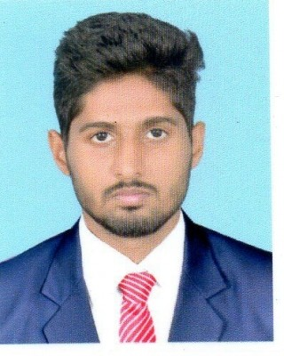

NABIL
NABIL.373500@2freemail.com

OBJECTIVES:
To be part of an organization where I will be able to achieve professional growth, as well as contribute to the development of the organization through dedication, efficient use of my skills and professional instinct.

EDUCATIONAL QUALIFICATIONS:

- Bachlor of Technology in Computer Science (2015)
(Cochin University of Science and Technology,Kerala, India.)

- Pre-University -Plus Two (2010)
(Board of Higher Secondary Examinations, Govt: of Kerala, India.)

Professional Certifications:

- Cisco Certified Network Associate – CCNA (2015)
(KeralaState Electronics Development Corporation Ltd.)
Course Content: training program for Routing & Switching (200-120).

- Certification in Draftsman (2017)
(InterCAD Systems (Pvt) – Trivandrum)
Course Content: Autocad 2D, 3D & Revit

- Diploma in Computer Management (2009)
(Sri Swathi ThirunalEducation Foundation)
Course Content: Web Designing, Graphic Designing & MS. Office

Computer Languages and OS:

C, C++, Java & PHP
Dos, Windows, Android

EXPERIENCE SUMMARY:

- 2 years of experience as a programming assistant in US based BPO Company.

Employment History:

1. Programming Assistant Aug’15 – Aug’17
M/s. Phoenix Technologies, Trivandrum, Kerala, India.
(BPO Services, Software Development etc.)
Responsibilities
- Co-ordination with clients
- Update the data to the concerned system.
- Follow up and updating.
- QC analysis and updation.

2. Business Development Executive Nov’14– Aug’15
M/s. Server & Clients, Trivandrum, Kerala, India
(Software Development and Marketing)
Responsibilities
- Marketing of Software Product
- Requirement Analysis.

LANGUAGES:

- English
- Hindi
- Malayalam
- Tamil

SKILLS:

- Under Standing of various software, clients etc.
- Effective Time management, Communication & interpersonal skills.
- Expert in MS Operating Systems & Databases.
- Supervisory & Managerial Skills

Reference:

Will be furnished on request

Availability
Notice Period: Can join immediate

PERSONAL DETAILS:
Date of Birth : Nov 17, 1993
Sex : Male
Marital Status : Single
Nationality : Indian
Languages Known : English, Malayalam,Hindi & Tamil

I do hereby declare that all the facts stated above are true to the best of my knowledge and belief.

