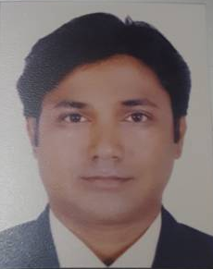 MARK
MARK.373506@2freemail.com

Manager - Client Relations
B-Com (Specializing : Marketing and Advertising)

With over 10+ years of experience, I would like to pursue a demanding role within a reputed firm with the approach to take up responsibilities to accomplish organizational goals where in my skills and potentials are being utilized to the maximum;

My Core Skills:

Co- ordination Client Relations Management Sales and Retentions

Complaints Management Business Transition Financial Consultant

Employment History

FinIndia Financial Consultants
Designation: Team Lead
Location : Pune, India
June 2013 – March 2017

Job Responsibilities:
- Managing the team and assist the team in achieving the targets
- Co-coordinating with clients and building network.
- Managing client meetings and preparing reports

Axis Securities Ltd
Designation: Business Executive
Location: Pune, India
Dec 2010 to May 2013

Job Responsibilities:
- Managing sales and organizational targets
- Co-ordination with bank clients
- Organizing and arranging client meetings
- Managing overall business transition

Andromeda Marketing Pvt Ltd.
Designation: Team Lead
Location: Pune, India
Jan 2010 to Nov 2010

Job Responsibilities:
- Managing the team and assist team in achieving the targets
- Co-coordinating with clients.
- Managing client meetings and preparing reports.

Metlife India Insurance Co. Ltd.
Designation: Sales Manager
Location: Pune, India
Feb 2009 to Dec 2009

Job Responsibilities:
- Recrute advisors and prepared their IRDA exam and Sales.
- Managing the team and assist team in achieving the targets
- Co-coordinating with clients.
- Managing client meetings and preparing reports.

Kotak Mahindra Bank
Designation: Business Executive
Location: Pune, India
Jan 2007 to Nov 2008

Job Responsibilities:
- Managing sales and organizational targets
- Co-ordination with bank clients
- Organizing and arranging client meetings
- Managing overall business transition

Personal Details

Name : Mark

Date of Birth : 12/10/1981

Any other details or personal references upon request …..

