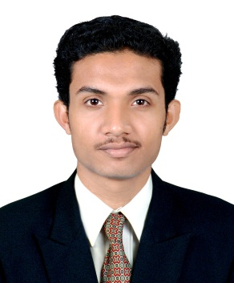
MOHAMED
MOHAMED.373510@2freemail.com

CAREER OBJECTIVE

It is submitted with the sole purpose of procuring an appropriate posting in your reputed firm in accordance with my educational qualification and experience. Being hard working and as an infallible performer in my consigned duties, I look forward to avail myself of an opportunity to carry out something accordingly and independently and the following details are given in order to you kind attention for me to have an appointmentin your concern.

SNAPSHOT
- Total5+years’ experience in AUTO CAD DRAFTSMAN
- Experience in Arecthecthural & Electrical Drawings.
- Experience in municipal drawings & submission
- Sound knowledge & experience in AutoCAD-2014,, MS office
- Self-confident, ambitious & energetic individual, who is consistent, well adaptive towards corporate culture and ability to work under pressure
EXPERIENCE PROFILE

Working with HYUNDAIENGINEERING&CONSTRUCTIONCO. LTD,Doha, Qatar.

Qatar National Museum (QAMU)

Role: Architectural -Draughtsman. BIM MODELERE DP(DIGITAL PROJECDT) april2012-aug2016

- Preparation of Shop Drawings.
- Preparation of As-Built Drawings.
- Preparation Coordinate Drawings.
- Maintain Drawing Server.
- Quality Checking of Drawings.
- Drafting Co-ordination.

- Plotting, Copying& Scanning of drawings
- Training new colleagues.
- Liaising with Technical &Construction Department.

Worked with VOLTASLIMITED,Doha , Qatar.

Msheireb Downtown Doha

Role: Electrical -Draughtsman. nov2011–mar2012

➢Drafting Electricalservices layouts using R & CAD.
➢Drafting services for Lighting layouts.
➢Preparation of Powar layouts.
➢Preparation of electrical room layouts
➢Preparing builders work layouts for all the services through wall and slab.
➢Coordinate the levels with all other services.
➢Preparation of schematic diagrams and air balancing of Electrical services.
➢Preparation of schematic diagrams for HVAC layouts & Drainage layouts.
➢Preparation of Electrical services shop drawings.

Worked with AL-JAZY BUILLDERS ,INDIA
Municipality Buildings, Office Buildings, Shopping Malls, Residential Apartments, Entertainment Parks, Cinema Theatres
Role: Architectural -Draughtsman may2009–oct2011

EDUCATION

1 Plus-Two in CMMERECE
2 TWO year NCVT in civil Draftsman
3 DIPLOMA IN A.I.T.E.S

COMPUTER SKILL
- AutoCAD,REVIT
- Working knowledge of MS Office
- Working knowledge of operating systems - MS Windows98, Windows XP

PERSONAL INFORMATION
Date of birth : 20thSEP1989
Nationality : Indian
Marital Status : Single
Languages known : English[R/W/S], Hindi [R/W/S], Malayalam& Arabic [R/W]

