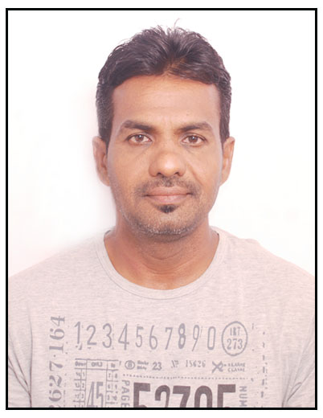

Vaman
Vaman.373512@2freemail.com
Apply for job posting: Maintenance supervisor

Career Objective:
To pursue a challenging career in Air-conditioning and ducting field in the reputed organization

Work Experience:

13 years work experience in Gulf & UAE.

- Worked as AC technician in Coronet canning company Karnataka –India from 1986 to 1990
- Worked as AC technician in Electronic Ltd Mumbai –India from 1990 to 1992
- Worked as AC technician in Abdul Rahman Al shaya Riyadh–KSA from1992 to1995
- Worked as HVAC tech GAMA Damam KSA from 1995 to 1999
- Worked as HVAC tech ENPCO Abudhabi –UAE from 2001 to2004
- worked as supervisor in HI TECH ELECTRO MECHANCIAL EST UAQ UAE from 2005 to 2008
- worked as Electrical contractors,in india Karnataka udupi. From 2010 to 2017
Building and house wiring and plumbing works ,.
- Duties and responsibilities :supervision of installation Dx units chillers AHU FCU,and Ducting Erection
- Installation & Maintenance to all type of Air-conditioning and refrigeration system.
- Installation & maintenance to all type of electrical components.and plumbing works.

Other Qualifications:
  - Auto Cad (Basic)
  - Basic computer(DCA and DTP)
  - Valid UAE Driving Licence

Educational Qualification:
      - S .S .L .C -1986
      - H .S .C - 1989
      - Diploma in Air-conditioning and Refrigeration
Personal Details:
Place of Birth : Malpe, Karnataka, India.
Date of Birth : 14-02-1968
Nationality : Indian
Languages : English, Hindi, Kananda, Malayalam and Tulu
Passport Details:

Place of issue : Bangalore India
Date of issue : 20-11-2014
Visa status: Visiting visa

I hereby declare that the particulars furnished above are true to the best of my knowledge and belief.

.

