Ahmed

Ahmed.373513@2freemail.com
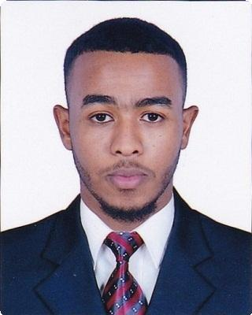

Personal information
Birth date: 19/8/1994

Marital status: Single

Religion: Muslim

Qualifications
Bachelor degree in Mechatronics engineering

Future university

Khartoum, Sudan

High school diploma

Alma`ali international private school

Abu dhabi, UAE

Education
Basic of light vehichles maintenance & | 31/5/2015 — 18/6/2015
repair
Vocational training & entrepreneurship center
Programmable logic control | 7/5/2017 — 19/5/2017
Sudan Turkish Vocational and Technical Trainers Education Center

Language
English Very good written & spoken

Arabic Native

1

Skills
Creative thinking
Attention to details
Communication skills
Work effectively under pressure Team work

Interests
Football
Racing
Cars
Volleyball

References
References available upon request.

2

