NIGHIN
Email : NIGHIN.373514@2freemail.com

To

The H.R .Manager

Dear Sir,

It is with great interest that I am forwarding my resume for your consideration. My record of academic achievements and professional career history, demonstrated attributes that make me a valuable employee. My resume is enclosed to provide you with details of my skills and accomplishments. But I am certain that a personal interview would more fully reveal my desire and ability to contribute to your organization.

Thank you for your time and consideration, and do not hesitate to contact me if you have any questions. I look forward to speaking with you soon

Thanking you

NIGHIN

CURRICULAM VITAE

Seeking a career in an organization with potential growth & prospects Where I can offer Something in terms of skill & knowledge to achieve organizational goal.

B.TECH

Field of Study : Engineering (Mechanical)
Institute : Palakkad Institute Of Science And
Technology, Kerala, India
University : Calicut university, Kerala, India
CGPA : 6.63
Pass Out Year : 2015
Plus Two

Field of Study : Science
Institute : N.H.S.S Engandiyur
Board : Kerala State Syllabus
Pass Out Year : 2010

Tenth Standard

Institute : K.N.M.V.H.S.S Thrithallur
Board : Kerala State Syllabus
Pass Out Year : 2008

- Completed Training Programme of ASNT-NDT Level II

- Liquid Penetrant Testing (PT)
- Magnetic Particle Testing (MT)
- Radiographic Testing (RT)
- Ultrasonic Testing(UT)

- Completed Training Programme of Quality Assurance and Quality Control in Welding Inspection
- Completed Training Programme of Piping Design and Engineering as per ASME B- 31.3

CAREER OBJECTIVES

NIGHIN

Personal Information:

Name : NIGHIN
Date of Birth : 07/06/1992
Gender : Male
Nationality : Indian
Marital Status : Single
Religion :Hindu, Ezhava

Address

Sharjah

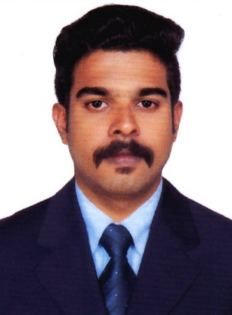
EDUCATIONAL QUALIFICATIONS

TECHNICAL QUALIFICATIONS

EXPERIENCE

- Worked as Supervisor at Johns Honda Motor Vehicle Department From 12th October 2015 to 20th September 2017

COMPETENCIES

- Willingness to learn new concepts
- Good leadership qualities and interpersonal skills
- Committed to deadlines and schedules
- Systematic and hardworking
ADDITIONAL SKILL

- Organizing Skills
- Co-ordination
- Team Work
- Creative thinking ability
- Presentation Skill
- Relationship Building

COMPUTER PROFICIENCY

.

- AutoCad 2D,3D
- Ms Office (Ms Word, Ms Excel and PowerPoint)
LANGUAGE SKILLS

- English
- Hindi
- Malayalam
DECLARATION

I here by declare that all the details furnished above are true and best ofmy knowledge.

