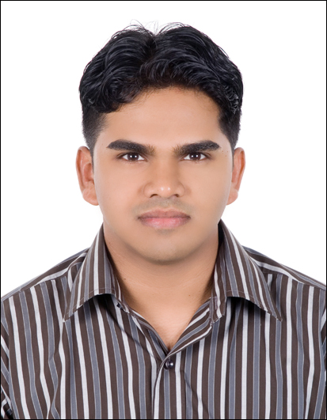 CURRICULUM VITAE

RUKFEED

RUKFEED.373522@2freemail.com

CAD DRAUGHTSMAN

OBJECTIVE
To join a reputed company in which I can perform, obtain, develop, improve and maintain the high quality standards of work in the field of engineering.

SUMMARY OF QUALIFICATIONS
I have been over 9 years of integrated experience in the field of Infrastructure Civil Engineering construction industry as a CAD Technician in India and U.A.E, been working in i) Multi-Storied Buildings, ii) Residential Buildings, iii) Interior Designing & iv) Infrastructure works.
Presently I am working as a CAD Draughtsman and As Built Coordinator, in MACE (Mechanical and Civil Engineering Co. LLC)

PROFESSIONAL EXPERIENCES
- M/s MACE (Mechanical & Civil Engineering Contractors LLC
- M/s MACE-ODESI (Joint Venture with ODESI Malaysia) Abu Dhabi, UAE
- M/s Al Masaood Bergum – Jabel Ali, Dubai.
- M/s U Muhammad Associates-Architects Engineers and Interior Consultants, India.

Present Employer : MACE
Project : Infrastructure development works
Designation : CAD Draughtsman

DESCRIPTION OF RESPONSIBILITIES HANDLED

Prepare all Kinds of 2d Drawings such as Structural and Civil drawings. Layout plan and profile for the portable waterlines and defense network, house connections, sewer networks, irrigation lines.

- Prepare and maintain the work log and transmittals and BOQ.
- Setting out details of alignment. (Structure and utilities)
- Typical details, Cross Sectional drawings and Sketches (Method Statements).
- Schematic drawings and Steel Reinforcement drawings
- Shop Drawings,
- HDD and Open Cut detail drawings
- New Route of networks, TPD Approval, TRANSCO Approval and Quantity takeoffs.
- Traffic management plans and layouts.
- Progress drawing and presentations for meeting
- As Built Drawings and file keeping

M/s MACE & M/s MACE – ODESI (From 19-04-2009 to 27-09-2017)
- Supply and install new meters for un-metered domestic water connections, connection pipeline replacements, meter replacements and modification works at different areas in al ain region (Project no. A-14278) – Ongoing

- Replacement of existing old mains and distribution water networks.

(Al Maqam District, Al Ain) (Project no. A-10915.1) - 2 years contract.

- Construction work associated with rehabilitation and replacement of existing sewer lines in Abu Dhabi Island. (Project no. O-2536) – 1½ years contract.

- Mace joint with odesi performing as-built data capturing and asset management solutions to asset intensive industries. Such as oil, gas and petrochemical, utilities & energy, building & infrastructure.
Designation: 3D Draughtsman/ Lazer Scanner (Point cloud).
- (Saudi Aramco, Jubail / Yanbu & Dusup Dubai). - 6 months for 3 Contract.
- (Dubai Supply Athourity, Dubai). - 2 months for 1 Contract

- Upgardation of al salam street, abu dhabi city ring road, contract no 1.
Salam street tunnel project. - 3 years contract.

M/s AL MASAOOD BERGUM, DUBAI (From 08-01-2008 to 15-02-2009)
Al Masaood Bergum (AMB) has been operating globally since 1978, building up a successful record for providing cost effective, fast and efficient building solutions.
Designation: Draughtsman – 1 Year
- Job responsibility: To prepare both plan and proposal drawings of Portable cabins for residential, offices, standard portable cabins and warehouses as per approved BOQ.

M/s U MUHAMMAD ASSOCIATES ARCHITECTS ENGINEERS AND INTERIOR CONSULTANTS, INDIA. (From Nov - 2005 to Dec - 2007)
- Job responsibility: Working in this Architectural firm as an AutoCAD draughtsman for preparing Interior layout plan, Residential plan, Apartment plan, Commercial Building plan etc. and to develop Exterior / Interior 3d model for the required.

SOFTWARE PROFICIENCY
- Autocad (2d, 3d & Isometric) Version 2016
- 3D Studio Max (Architectural Presentation)
- Archicad
- Basic Knowledge in Revit Architecture
- Basic Knowledge in Bentley MicroStation
- Adobe Photoshop and additional image editing softwares aside
- Image Animation & Presentation Softwares
- MS Office (2003 - 2013)
- Hyper Text Markcup Language (HTML)

ACADEMIC
- Diploma in Draughtsman Civil – NCTVT (2003 - 2005)
- Diploma in AutoCAD Engineering (2005)
- Certificate Course in 3D Studio Max (2009)
- Higher Secondary (2000 - 2002)
- SSLC (2000)

PERSONAL DETAILS
Date & Place of Birth : 12th December. 1982 / Kerala, India
Age : 35
Nationality : Indian.
Height : 5 ft. 6 in.
Weight : 81 kg
Marital Status : Married
Dependents : 2
Visa Status & Date of Expiry : Resident Visa (02-08-2018)

FUTURE PERSPECTIVES

Seeking further improve my career prospects and consequent growth, and looking for a suitable position in company where I can contribute the best of my skills and efforts in the growth of the company and myself. I aspire to apply my knowledge and skills acquired in my academic career and software proficiency for the fulfillment of the Organization objectives and implement with perfection in every sectors.

I hereby attest that all the information and statement written above are true and correct.

Signature:

