UNNIKRISHNAN
UNNIKRISHNAN.373524@2freemail.com
Karama, Dubai
Key Skills  Project Management  Installation & Commissioning  Cost & Resource Optimization  Site Operations  Planning & Scheduling  Quantity Surveying  Quality Assurance & Control  MIS Reporting & Documentation  Team Management | Targeting senior level assignments in  Project Management in a leading organization of repute in Construction industry in Gulf countries
 | Profile Summary
- B.E. (Mechanical) with over 10 years of experience out of which 4 years of experience in QATAR NAFFCO.
- Expertise in Project Management, Installation & Commissioning & Man Management with key focus on profitability and optimal utilization of resources
- Proficient in planning, executing & heading projects involving method engineering / method statement, development and resource planning
- Skilled in adopting modern methodologies in compliance with quality standards; conducting quantity surveys for construction projects
- Expertise in swiftly ramping up projects in close coordination with contractors, consultants, architects and other external agencies, ensuring on- time deliverables
- Gained exposure in the installation, testing & commissioning of Fire Sprinkler Systems, Fire Hydrant System, FM 200 System, Deluge Water Spray System, Foam System, Fire Alarm System, Public Address System, Access Control System and CCTV
- Comprehensive knowledge and understanding of Firefighting Techniques, NFPA and Life Safety Codes
- An innovative & result-orientated professional with strong planning, communication, interpersonal & negotiation skills.
- Presently Available in UAE on a Visit Visa which will get expired on 16/12/2017.
Career Timeline
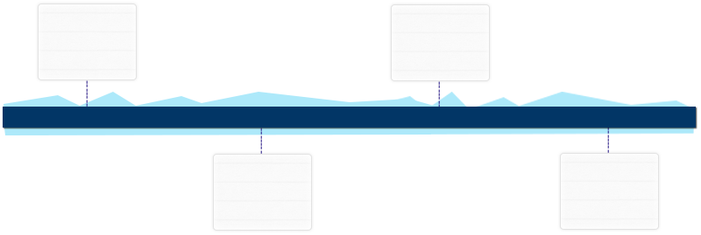
NAFFCO (National Fire Fighting Company), Qatar as Project Engineer
Firepro Systems Pvt. Ltd., Bangalore as Engineer-Client Delivery
2012-2017
2009-2012
HCL Infosystem Ltd., Kochi as Project Engineer
Cherytech India Pvt. Ltd., Kochi as Site Engineer
2008-2009

2006-2007
Education
- B.E. (Mechanical Engineering) from Visveswaraya Technological University, Karnataka in 2006

Work Experience
Dec’12-Feb’17 with NAFFCO (National Firefighting Company), Qatar as Project Engineer

Key Result Areas:
- Planned and scheduled the project baselines; monitored and controlled projects with respect to cost, time overruns and quality compliance for satisfactory execution
- Collaborated with site engineers, supervisors, workers, sub-contractors and subordinates for executing the project operations within the stipulated time
- Prepared periodic status & cost reports for updating the management of project progress
- Led the operations pertaining to erection & commissioning of fire protection and detection system as per NFPA standards and completed project in minimum turnaround time
- Analyzed and studied the drawings of various systems and executed the work as per the plan and time schedule
- Mitigated risks of the projects as well as planned for contingencies
- Built & maintained healthy business relations with vendors / suppliers and achieved delivery & service quality norms
- Administered the billing/invoicing along with documents for the project and updated the progress to immediate reporting person; ensured documentation & verification of bills & invoices as per the company policies
- Maintained a track of the inventory and reported the same to the head office for smooth operations

Highlights:
- Recognized with NAFFCO’s “Top Achiever Award” for the year 2014, 2015
- Managed the onsite project management functions for Hamad International Airport Project, Qatar Rail Project & Ras Abu Fontas Project, which includes Scope, Time, Cost, Human resources, Communication, Quality, Procurement & Risk Management
- Initiated Health, Safety and Environmental measures which includes, training of personnel for accident prevention, accident response, emergency preparedness and waste management thereby resulting in reduced costs / cycle-time of the Projects
- Administered the construction & widening for fire protection and detection systems at Kahramaa substation projects worth US$ 7 Million for Qatar General Electricity and Water Corporation
- Initiated the timely execution of Hamad International Airport project within budget; implemented cost control techniques such as Earned Value Management as well as effective estimates to access whether the Project is on track
Aug’09-Nov’12 with HCL Infosystem Ltd., Kochi as Project Engineer
Key Result Areas:
- Performed installation, testing and commissioning of CCTV and Access Control Systems
- Headed the team of supervisors and subcontractors and coordinated with assisting staff to ensure the quality work
- Managed the billing/invoicing with requisite documents for the project assigned
- Facilitated the customers with after-sales support once the system is installed
- Updated the project status to the senior management through project progress reports

Previous Experience
Jan’08-Jul’09 with Cherytech India Pvt. Ltd., Kochi as Site Engineer
Dec’06-Dec’07 with Firepro Systems Pvt. Ltd., Bangalore as Engineer-Client Delivery

IT Skills
- Microsoft Word
- Microsoft Excel
- Microsoft Project

Personal Details
Date of Birth: 4th April 1984
Languages Known: English, Hindi, Malayalam and Kannada
Driving License: Having Valid Qatar Driving License.

(please refer to annexure for major organizational projects)

Annexure
Organizational Projects

NAFFCO (National Firefighting Company), Qatar
- Hamad International Airport Project- Doha Qatar
- Qatar Rail Project
- Ras Abu Fontas Project
- Hamad Medical Corporation project
- Kahramaa Substation Projects

HCL Infosystem Ltd., Kochi
- Cochin Special Economic Zone Project
- Kerala State Electricity Board Project
- Cochin International Airport Limited

Cherytech India Pvt. Ltd., Kochi
- Leela Info Park Project
- Indian Medical Association Project

Firepro Systems Pvt. Ltd., Bangalore
- Accenture at Divyasree Technopark, Bangalore
- Divyasree Technopark, Bangalore

