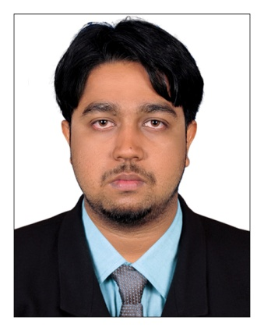  Email:  MANEESH.373526@2freemail.com  Driving License:  India  Languages Known:  English, Malayalam &  Tamil  Current Address:  Al ain ,Abudhabi ,UAE  Visa Status:  Visit visa  (valid till to 01 jan 2018) | CURRICULUM VITAE  MANEESH  MANEESH.373526@2freemail.com  CAREER OBJECTIVE  To explore opportunities in the ever changing business world and seek a challenging career position in the field of business and management in order to leverage my skills and make significant contributions to the society and business.  area of expertise  - Book keeping  - Inventory valuation  - Value Added Taxes like input,output  - Cash dealings  - Sales  - Partnership firm Accounting.  - Tally Erp 9  work/professional experience  1. SUPER STEEL FURNITURE INDUSTRIES ,TANALUR,INDIA  Designation : Accountant cum Sales assistant  Period : June 2016 to February 2017  Roles/Responsibilities  - To maintain Daybook and ledgers  - To support the firm sales for high growth  - Updating accounts receivables and issue invoice  - Preperation of final accounts and valuation of stock  - To maintain payroll  - To maintain bank related dealings  - To keep purchase and sales register correctly
2. ACCURATE SOLUTIONS, INTERNAL AUDITORS CHAGARAMKULAM, INDIA

Designation : Accountant Trainee/Assistant
Period : Janunary 2015 to January 2016

Roles/Responsibilities

- Assistance in internal audit
- Preperation of wages and salary list
- Asset management (acquisition,sale,transfer,written off)&depreciation
- Managed accounts receivable and accounts payable
- To assist senior accountant for the preperation of monthly or yearly closings
- Handling payroll
- Preperation of Book of accounts
- Maintaining Day book,Cash book,Journal register,Purchase&Sales register,etc in electronic as well as paper mode.

EDUCATIONAL QUALIFICATIONS

- M.com with finance (Madurai kamaraj university) - Pursuing
- B.com with co-operation(Calicut university) - 2014
- Diploma in Business Accounting - 2011
- Nebosh IGC - Pursuing
- Iosh MS - 2014
- Diploma in Health and Safety management(DHSM)
approved by IIRSM-UK - 2014
- Basic CPR and Medic first aid
COMPUTER PROFICIENCY

- Expert in using MS OFFICE.Also basic knowledge of financial and statistical modeling using MS EXCEL
- Experience in using tally erp9
- Experience in Accounting packages
- Mail and Internet

DECLARATION
I hereby proclaim that the enlisted facts are authentic to the best of my knowledge

