CURRICULUM VITAE
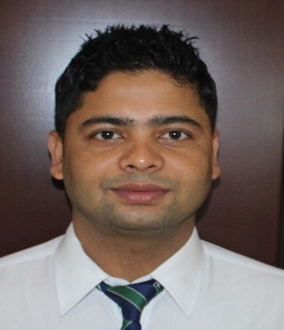
LAXMAN
LAXMAN.373530@2freemail.com

Objective:-

To pursue a dynamic and challenging career as a MRI-CT - X RAY TECHNOLOGIST & TEACHING FACULTY which provides me a platform to contribute to the organizational growth by utilizing my skills & knowledge and add value to myself through continuous learning.

EXPERIENCE:

Radiographer- Aster DM Healthcare – Alqouz Dec 2015- Till date

- Perform diagnostic imaging procedures using computerized radiology equipment PACS RIS System, CR and DR technology.

- Conducts all general radiography examinations in accordance with department procedures and protocols; uses special low dose techniques, positions patients, select technical factors and adjust equipment parameters taking into consideration physical differences in patients and make exposures necessary for the requested procedure.

- Assesses images produced for best quality, checks appropriateness and completeness before forwarding to Radiologist for review and reporting
- Maintains a clean, organized and tidy workplace, including cleaning of equipment and restocking of supplies.
- Deals with patients and clinical staff regarding initial inquiries and relays where necessary.
- Accomplishes all other duties as assigned by Supervisor, Group Radiology Manager and Operations Manager.

Senior Radiological Technologist, Chitwan medical college and teaching hospital, Nepal 18 Sep 2014 -26 Oct 2015

- Performs MRI(1.5T PhilipsAchieva) scanning routine and special cases DWI,Angio,Spectroscopy,Dynamic study,MRCP
- Daily checking of Helium level, cooling cabinet LLC,

- Help to Find outs errors on the technical rooms.
- Receives patients and explain method of procedures and claustrophobia.
- Assist Radiologist for reporting.
- Teaching and guide Diploma radiographic students.
- Monitors and maintains safe and healthy environment by minimizing hazards and risks in the workplace.

RadioTechnologist Lumbini Medical College & Teaching hospital, Nepal 29 May 2012 to 26 Nov 2014.

•To perform routine and special CT scanning (Dual slice Siemens Somatom Emotion)

•Conduct diagnostic imaging & radio logical procedures including urinary tract, Barium study, Biliary study. •Conducts diagnostic imaging procedures CR technology.
•Monitor condition of CT/X-ray machine and accessories

•To maintain Duty roster of all radiographers
•To assist Radiologist & co radiographers.

- Monthly checkup of cracking of lead aprons and monitoring radiation leakage.
- Check the quality of CT scan & X ray.

Education

Degree | Major subject | University/Board | Year | Division
BSC. MRIT | Anatomy, Physiology, Radiation | HNB Garhwal University,
(Radio imaging Technology) | Physics, Radiographic | Garhwal,Srinagar (Uttarakhand) India, | 2008-2011 | First
 | Techniques, Special | Shri Guru Ram Rai Institute Of Medical |  | (70 % )
 | Radiological Procedure, CT and | And Health Sciences, Dehradun, India
 | MRI, Radiation Therapy

Clinical Internships

Heritage Hospital PVT LTD Radiographic Intern (Oct 2012-april 2012) Varanasi, India (up)
Rotation: MRI, CT, General Radiography, Special Radiographic Procedures, Operating Room

Skills

- Knowledge of the latest radiology room equipment/systems, procedures and safety standards with the ability to convey information to patients effectively

- Competent, sensitive and personable with patients

- Organized with excellent time management and prioritization skills.

Equipment Handled/Used:

- Efficiency with PACS Filmless Radiology System

- Equipment Operation: Philips achieva tx 3T MRI/ Philips achieva 1.5 T Siemens Dual slice CT scanner Somatom Emotion Duo,GE 16slice CT

- All radiographic Diagnostic equipment including CR technology, Medritonics 500MA, siemens axiom,Listem 500MA

- Konica minolta , Agfa Processor, Agfa Digitizer.

Licensure and Examinations

• Dubai Health Authority (DHA), Full-Time License, DHA-P-0144082, ED: 03/10/2016

• Nepal health profesional councile Parmanent License Number: A 197 RD, ED: 15/08/2020

Personal Data

Name: | Laxman | Marital Status: | Single
Son of: | Mr. Ram datta Bhatt and Mrs Kausha Devi | Nationality: | Nepali
 | Bhatt
Date of Birth | Aug 22, 1989
Sex | Male

References available upon request

I hereby declare that all the above information’s mentioned are truth and faithful in best of my knowledge.

