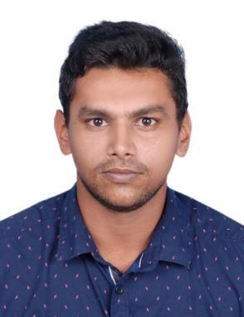
NAMEER

CIVIL ENGINEER

Nameer.373532@2freemail.com

Abu Dhabi, United Arab Emirates

Have valid UAE Driving License and driving experience of 3 years.

CAREER OBJECTIVE

EDUCATION

PROFESSIONAL SKILLS

To be associated with a progressive organization that gives the scope to apply my knowledge and skills, and to be a part of a team that dynamically contribute towards the personal and organizational development.

Bachelor of Technology in Civil Engineering
National Institute Of Technology
Karnataka, India
May, 2017

Central Board of Secondary Education, Class XII Sunrise English Private School Abu Dhabi, United Arab Emirates 2012

- Professional AutoCAD 2D, 3D

- Remarkable knowledge on Structural and Architectural elements and procedures in construction and its supervision

- Quantity Surveying and tendering procedures

- ETAB Basics

- Microsoft Office tools including MS Excel, MS Word, MS PowerPoint

- Adobe Photoshop Basics and others like Acrobat Reader, PDF

- Coding Languages C and C++

PROFESSIONAL ▪  Project paper accomplished on Satellite land use/land cover surveying using
ACCOMPLISHMENTS ERDAS
▪ Practical Training at the project Manjunikethan, Marian projects,
Mangalore.
▪ 4 months working experience at the project MMH school renovation,
Shaduli mosque and framed structure building at edappally, at Naser

associates architects and consultants, Calicut. (from May, 2017)

Page 1 of 2

EXTRA CURRIULAR ACTIVITIES

- Attended the annual sports meet in 2009 at all Kerala basketball tournament.

- Worked as an active member of DDFC club which is part of campus exclusive clubs.

- Worked for incident publicity on 2016 as a core member.

- Conducted Hogathon in 2017 under supervision of incident specials committee.

LANGUAGES
KNOWN |  |  | Languages |  |  | Read | Write | Talk |  | Talk Fluently
 |  |  | English |  |  | ✓ | ✓ | ✓ |  | ✓
 |  |  | Arabic |  |  | ✓ | ✓
 |  |  | Hindi |  |  | ✓ | ✓ | ✓ |  | ✓
 |  |  | Malayalam |  |  | ✓ | ✓ | ✓ |  | ✓
 |  |  | Tamil |  |  |  |  | ✓

Page 2 of 2

