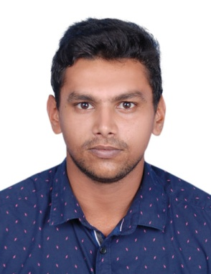
NAMEER

CIVIL ENGINEER
NAMEER.373533@2freemail.com
Al Khalidiyah, Abu Dhabi, United Arab Emirates
Have valid UAE Driving License and driving experience of
3 years.

CAREER OBJECTIVE | To be associated with a progressive organization that gives the scope to apply my knowledge and skills, and to be a part of a team that dynamically contribute towards the personal and organizational development.
EDUCATION | Bachelor of Technology in Civil Engineering  National Institute Of Technology  Karnataka, India  May, 2017  Central Board of Secondary Education, Class XII  Sunrise English Private School  Abu Dhabi, United Arab Emirates  2012
PROFESSIONAL SKILLS | - Professional AutoCAD 2D, 3D  - Remarkable knowledge on Structural and Architectural elements and procedures in construction and its supervision  - Quantity Surveying and tendering procedures  - ETAB Basics  - Microsoft Office tools including MS Excel, MS Word, MS PowerPoint  - Adobe Photoshop Basics and others like Acrobat Reader, PDF  - Coding Languages C and C++
PROFESSIONAL ACCOMPLISHMENTS | - Project paper accomplished on Satellite land use/land cover surveying using ERDAS  - Practical Training at the project Manjunikethan, Marian projects, Mangalore.  - 4 months working experience at the project MMH school renovation, Shaduli mosque and framed structure building at edappally, at Naser associates architects and consultants, Calicut. (from May, 2017)

EXTRA CURRIULAR ACTIVITIES | - Attended the annual sports meet in 2009 at all Kerala basketball tournament.  - Worked as an active member of DDFC club which is part of campus exclusive clubs.  - Worked for incident publicity on 2016 as a core member.  - Conducted Hogathon in 2017 under supervision of incident specials committee.
LANGUAGES KNOWN | Languages Read Write Talk Talk Fluently  English  Arabic  Hindi  Malayalam  Tamil

