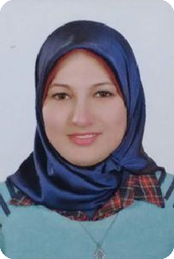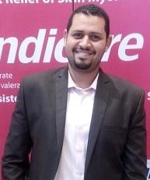
Ahmad

OBJECTIVES

Trying hard to find a job matching with my academic and career pathway, which will help me gaining new experience and appropriate life style.

PERSSONAL INFORMATION
Name: Ahmed
Nationality: Egyptian Marital Status: Single
Address: AL JAFILYAH, DUBAI
Age: 35 years old
E-mail: Ahmed.373537@2freemail.com

PROFESSIONAL EXPERIENCE
District sales Manager pharmaceutical company Employment date (1/2015- till sep 2017)
I WORKED for three years at ALESRAA pharmaceuticals and I was responsible for managing team of medical sales representatives to achieve company goals.
[Implement mission and vision for our company in market
– making my zone forecast and plan to achieve it – making targeting, positioning and segmentation for my medical market – setting tactics to achieves my target throw my team - achieves target – get customer loyalty and retention– improve team skills and making customer need satisfaction].
Results {one of the Best achievers for 3 years all over the country}.

Area sales Manager
Employment date (1/2013- till October 2015)
For two years at Macro Group Pharmaceuticals. My job description was:

Ahmad
Leader and manager for 28 medical sales representatives and 2 supervisors
Average of this period achievement is 95 %

Filed force Manager at macro group
Employment date (from 2006- till 2013)
Team leader and coacher for 7 medical representatives
Responsible for leading and apply tactics for my team to achieves company target

Medical sales representative at macro group

Employment date (from 2004- till 2006)
Selling company products, negotiation with different categories of Physicians and customers, have the talent to discover the customer need and make satisfaction for it, have the ability to classify the targeted customer personal to help choosing the appropriate propping to talk with him and a very good presentation& medical information

SALES:
I always was one of the best achievers all over the country because I always accept challenges and keen to make time management and have a strategy & plan to follow.

TEACHING:
I was responsible for medical training of the company drugs portfolio, so I am a good presentation preparer with wide knowledge and very good communication and presentation skills that help in making everything clear during the sessions.
Also, responsible for the development of my team with different titles [medical sales representative – senior manager – supervisors - filed force manager]
With my TOT program.

Ahmad
EDUCATION
BACHELOR OF SCIENCE | 2004 ALEXANDRIA UNIVERSITY, EGYPT
MAJOR: Zoology
MINOR: Chemistry
BUSINESS ADMINSTRATION DEGREE
from Arab academy for science and technology

PERSONAL SKILLS
Excellent Communication & negotiation skills, problem Solver, ambitious, intelligent, open minded, helpful, patient, Creative, organized, hard worker and self- motivated.

Selling courses
Selling Skills - Area manager sales analysis - Sales forecast

Personal courses
Communication skills - negotiation skills - conflict management

Management courses
Leadership management – coaching - budget, target forecasting

Marketing courses
CRM "Customer Relationship Management" grad A Essential Management grad A Business Administration Courses
Strategic Management Grad A
Principles of Management Grad A

All courses certificates are available also experience letter with all previous jobs.
THANKS

