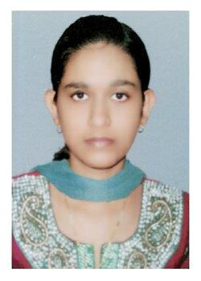
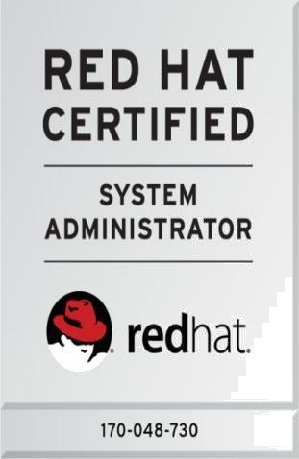

SHILPA

Email: shilpa.373565@2freemail.com

Objective

To get employed in an organization where I can utilize my knowledge for the growth of the organization.

Certification

Red Hat Certified System Administrator (RHCSA)-Certificate Number: 170-048-730

IT Proficiency

- JAVA

- .NET

- C PROGRAMMING

- PYTHON

- MYSQL

- COMPUTER SKILLS: MS Office (Word, Excel, PowerPoint), LaTeX etc.

- OPERATING SYSTEMS: Windows XP, Windows7, Linux, Ubuntu, RHEL7.

Accomplishment

- Developed VIDEO LICENSE PLATE CHARACTER EXTRACTION system as B.tech main project in JAVA

- Developed (Website of carrier guidance) SUCCESS KEY as B.tech mini project in

.NET

- B.tech Internship in JAVA &ANDROID

- Developed PRIVACY POLICY PREDICTION FOR USER UPLOADED IMAGES ON SOCIAL NETWORKING SITES as M.tech mini project in JAVA.

- Developed AN EFFICIENT MULTI-LABEL CLASSIFICATION SYSTEM USING ENSEMBLE OF CLASSIFIERS as M.tech main project in java is accepted for presentation and publication in IEEE International Conference (ICICICT 2017).

Educational Qualification

Board/University | Institution | Qualification | Pass Out Year | %Marks/CGPA
APJ Abdul | College of | M.tech | 2017 | S1: 7.00
Kalam | Engineering |  |  | S2:8.21
technological | Cherthala |  |  | S3:8.31
university |  |  |  | S4:8.5
MG University | Christ | B.tech | 2015 | CGPA :6.62
 | Knowledge City
KERALA | Govt HSS | 12 th | 2011 | 85%
 | Chandiroor
KERALA | Vaduthala | 10 th | 2009 | 81%
 | Jama-ath HSS

Inter Personal Skills

- Dedicated

- Hardworking

- Team management

Personal Details

•

NAME

: SHILPA

• | AGE | : 23
• | DOB | : 18/04/1994
• | NATIONALITY | : Indian
• | RELIGION | : Hindu (Nair)
• | MARITAL STATUS | : Married

- LANGUAGES KNOWN : English, Malayalam

• HOBBIES : Google Searching, Listening Music

Extra Curricular Activities

Won many prizes for competitions held in school and Sub District levels

Declarations

I do hereby declare that the above information is true to the best of my knowledge.

Place: Aroor SHILPA

Date: 2/10/2017

