SHAJI.
SHAJI.373574@2freemail.com
DIPLOMA IN CIVIL ENGINEERING
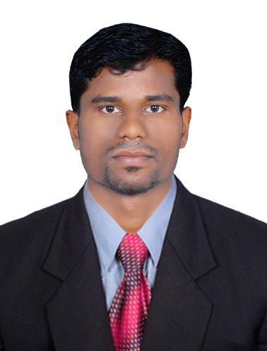
CAREER OBJECTIVE:
PERSONAL PROFILE:
- Seeking To take managerial position in the field of Civil Engineering and take Challenging, creative and diversified project.

QUALIFICATION:

- Diploma in Civil Engineering, (2010-2013)
(First Class), Council for Technology & Science Kerala.
- SSLC, (2010) National Institute of Open School, Government of India.

Email:
SHAJI.373574@2freemail.com
TECHNICAL SKILLS:
- Auto CAD @D & 3D (Certified Professional)
- Revit Architecture
- 3DS Max Design
- Adobe Photoshop CS2
- MS Office Packages (98 - up to 2010)
- windows (95-98/XP/vista/windows 7/8/10)
- Internet Applications

Personal Data:
Date of Birth : 28-11-1989
Gender : Male
Marital Status : Single
WORK EXPERIENCE:
Nationality : Indian
- As ‘Auto Cad Draughtsman’ from (2014 August- 2017 August), in Aiswarya Developers, Chelakkara, Thrissur District, Kerala, India.
Mother Tongue : Malayalam
Visa Status : Visit visa
Visa Expiry : December 25
Languages Known:
- Roles & Responsibility:
(Read, Write and Speak)
- Preparation of detail drawings of various types of structures (R.C.C & Composite) section making 2D models of multistory building.
- Preparation of detail drawings of various types of buildings like Warehouse, Elevations & Multistory building.
- Dimensions Designing and Software Management
- Used various statistical and engineering techniques to handle the engineering projects given by senior engineers.
- Undergone training on handling complex engineering technique’s & tools, which gave an in depth understanding to solve complex problems with and efficiency.
- Took up challenging designs, and I had put my efforts efficiently and effectively finished the project in the stipulated time and thereby satisfied customers.
- English
- Hindi
- Malayalam
- Tamil (Only Speak)

PERSONAL STRENGTHS:

- Good understanding ability
- Careful observation &
Co- ordination
- Good communication Skills
- Easily adaptive

PERSONAL INTERESTS:
- Key Experience in Summary:
- Experience in Architectural & Designing Sector.
- Experience in detail drawing of reinforced concrete & Steel
- Experience in detail drawing of composite structures like Warehouse, High Rise buildings, Elevations.
- Football
- Music
- Films
- Reading

- Experience in detail drawing of 2D Structural details.
- Experience in Solving Auto Cad technical issues and leading the CAD Team.

DECLARATION:

I hereby proclaim that all the above information furnished by me is true to the best of my knowledge. I assure you that all I will emancipate my duty to best of my aptitude and to the entire satisfaction of my superiors

Date:
Place: Dubai
Sincerely,
Shaji.

