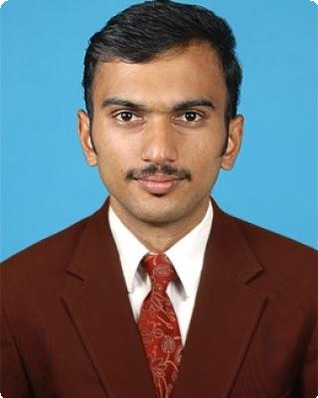
Shaheen

E-mail : shaheen.373578@2freemail.com

PERSONAL SUMMARY
A competent IT support professional with a proven track record of providing specialist technical and help desk support. Extensive experience of working in the

frontline helping clients and colleagues resolve complex technical IT issues. Possessing excellent client facing skills, natural problem solving and analytical skills and able to contribute to the development of best practice, procedures and policies within a company.

PERSONAL & CONTACT INFORMATION
Nationality: Indian

Languages known: English, Hindi, Arabic & Malayalam

Year of Birth: 1990

Gender: Male

Marital Status: Single

Visa Status: Employment Visa (Transferable)

Work experience
Oxygen Digital June 2012 — May 2013

Laptop & Desktop Technician.

1. Oxygen Digital

Kerala-INDIA

Oxygen digital shop is the division of Ozone Systems, Ozone Systems is now one of the leading names in the Kerala IT distribution scenario. With the support and cooperation of over 200 IT manufacturers and all its customers and well wishers, Ozone Systems ventured into the retail sector with Oxygen-the digital shop. The vision of Ozone is to become the No.1 technology provider in Kerala, India.

Responsibilities:

·Design, Implementation and maintenance of Structured & Wireless LAN.

·Configuration of ADSL internet routers, network printers, plotters etc.

·Installation and configuration of Windows server based networks & application software.

·Provide backup and virus solutions.

·Assembling and troubleshooting of Desktops.

Shaheen. 1

·User creation, printer management & Software installation. ·Expansion of network using hubs and switches.

·Trouble shooting of hardware related issues.

West Ruwais Systems and Services LLC. November 2013 — November 2015

System Support Engineer

DETAILED SUMMARY:

2. West Ruwais Systems and Services LLC. Abu Dhabi-UAE.

West Ruwais systems, the leading IT solutions provider in Abu Dhabi, UAE is being supported clients in IT aspects on the ADNOC housing division in Abu Dhabi.

Responsibilities:

·Responsible for diagnosing & resolving hardware, software & end users problems. ·Acting as the first point of contact for all IT & technical queries.

·Developing the infrastructure and systems to meet the companies needs.

·Working within a TCP/IP network environment, including DHCP, DNS and Ethernet. ·Involved in the rollout of software updates and patches.

·Investigate specialist and complex IT support issues. ·Communicating with third party technical specialists. ·Configuring and managing backup & restore procedures.

·Maintaining a wide range of computer hardware and software programs. ·Identifying & reporting on the budgetary implications of IT projects and upgrades. ·Provide secondary support for LAN administration.

·Responsible for allocating work to junior staff and induction training for new staff. ·Deploying new hardware, server backups & evaluating new software & security risks. ·In-depth knowledge of Microsoft Windows client operating systems, XP, Vista, Windows 7/8.

Modern Computer Systems and Service

LLC.

System Support Engineer.

DETAILED SUMMARY:

November 2015 — Still continuing...

3. Modern Computer Systems and Service LLC.Abu Dhabi-UAE.

Modern computer systems, the leading IT solutions provider in Abu Dhabi, UAE is being supported clients in IT aspects on the ADNOC housing division in Abu Dhabi.

Responsibilities:

Computer formatting and assembling.
Router Configuration and networking.
CCTV camera fixing.

Shaheen. 2

Qualifications
Bachelor of Computer Science (BSc CS)

Calicut University, Kerala-India (Yr 2009-2012)

Education
SSLC | — March 2007
A.S.M.M.H.S.SCHOOL
Higher Secondary School | June 2007 — June 2009
G.H.S.S. ERIMAYUR
Bsc. Computer Science. | June 2009 — July 2012
COLLEGE OF APPLIED SCIENCE, KOTTAYI

Interests
1.Seek advanced techniques useful for applications. 2.Listening music.

3.Internet surfing.

References
References available upon request.

Shaheen.A 3

