 |  |  |  |  | Curriculum Vitae
 |  |  |  |  | Objective
 |  |  |  |  | Looking forward with wide practical caliber to work with a
 |  |  |  |  | reputed organization that gives me an opportunity where I can
 |  |  |  |  | prove my abilities and which provides an environment to share my
 |  |  |  |  | skills with others so that I will be a part of success in that
 |  |  |  |  | organization.
Name. JOYS
 |  |  |  |  | Profile
email. Joys.373583@2freemail.com |  |  |  |  | 24 Years of experience as a show room in charge including
 |  |  |  |  | customer service, Procurement, Stock control, training and safety
 |  |  |  |  | issues.
 |  |  |  |  | Enjoys challenges and effectively working as a team player
 |  |  |  |  | under pressure to achieve consistent results for the organization.
 |  |  |  |  | Education
 |  |  |  |  | Diploma in Electrical Engineering, 1990
 |  |  |  |  | Airco Technological Institute, Kerala
 |  |  |  |  | Recognized by the Government of Kerala
Personal Details |  |  |  |  | Secondary School Leaving Certificate, 1985
D.O.B. |  | 14/05/1969 |  |  | Department of Education Kerala State
Nationality. |  | INDIAN
Marital Status. |  | Married. |  |  | Computer Skills
Passport Details |  |  |  |  | Electrical AutoCAD
Place of Issue. |  | Dubai |  |  | Peachtree Accounting
Date of Issue. |  | 28/02/2013
Date of Expiry. 28/02/2013 |  |  |  |  | Technical Skills
Visa Status |  |  |  |  | Design and estimation of DBs, MDBs (up to 3200A), Capacitor-
On transferable visa |  |  |  |  | Banks, Light Control Panels and all types of MCCs.
Languages Known |  |  |  |  | Testing and commissioning of LV.MV panels.
English, Hindi, Malayalam
Arabic (Spoken) |  |  |  |  | Knowledge of local authority system requirements.
Driving License |  |  |  |  | Familiar with Fire Control Panels and PLCs.
Valid UAE Driving License
Date of Expiry. 14/06/2018 |  |  |  |  | Familier with documentation as per ISO standard
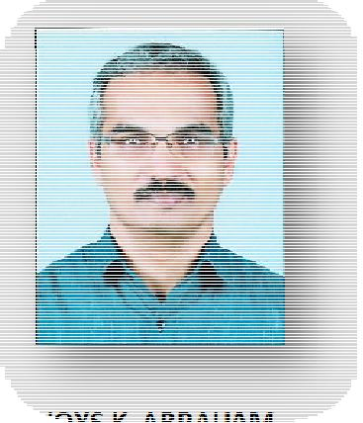

Professional Experience

Khail Electrical Trading LLC, Ras Al Khaimah

Designation : Showroom In charge.

Duration: May 1993 to August 2017

- Day to day running of Showroom and Store

- Improve organizational skills

- Comply with company policies and procedures

- Responsible for achieving sales targets

- Responsible for procurement and stock control

- Delivering a high standard of customer service

- Motivating and training staff to achieve monthly sales targets

- Proper documentation for all above as per ISO 9001-2000 standards

References

References can be provided on request.

