CURRICULUM VITAE
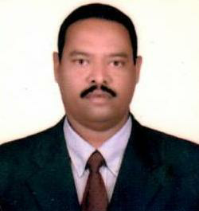
CHAND
CHAND.373587@2freemail.com

United Arab Emirates

OBJECTIVES:
A Committed, diligent and proactive person, excellent team player with the ability to motive people, follow up as well as provide leadership, natural flair for effective communication. Strong interpersonal skills and ability to take initiative, makes suitable for any position.
PERSONAL DETAILS:
Nationality : Indian
Date of Birth : 10/01/1972
Place of Birth : Nallamada AP
Gender : Male
Religion : Islam
Marital Status : Married
EDUCATIONAL QUALIFICATION:
- S.S.L.C , Intermediate
WORKING EXPERIENCE:
  - Worked as a Jewelery Salesman in Alam Dahab Tabuk in K.S.A for 5 years.
- Worked as a Salesman L.P.G cylinder at Brother Gas in Ajman, Dubai, 8 years
- Worked as a Salesman Cum Driver at Al Fouz Gas Supply in Ajman, Dubai, UAE for
1 years.
- Worked as a House Driver
- 1 year 9 months
- Driving:U.A.E Driving license (3years Driving experience)
Skills:UAE driving license
LANGUAGES KNOWN:
English , Arabic & Hindi ,Telugu
DECLARATION
I hereby declare that above mentioned details are true to the best of my knowledge and belief. I assure you that I will discharge all my duties entrusted to me to the entire satisfaction of all concerned.

