CURRICULUM VITA 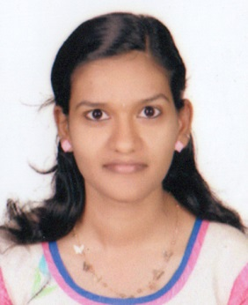
AKHIL

AKHIL.373603@2freemail.com

CAREER OBJECTIVE

To work in a stimulating environment where I can apply and enhance my knowledge and skill to serve the firm to the best of my efforts.

EDUCATIONAL PROFILE

Degree/Qualification | Name of the Institute/School | University/Board | Marks Scored | Year of Passing
MBA  (Major-HR)  (Minor-MARKETING) | Mar Athanasious College For Advanced Studies Tiruvalla | Mahatma Gandhi University | waiting for result. | 2017
BA English language and literature | NSS Hindu college Changanasherry | Mahatma Gandhi University | 76% | 2015
Higher Secondary Education | St.Thomas HSS Kozhencherry | HSE kerala | 78% | 2012
Secondary School Certificate | St.Mary’s GHS Kozhencherry | SSLC | 85% | 2010

TECHNICAL SKILLS
- Soft Skills : MS Office

EXPERIENCE/ PROJECT

- Study on Influence of welfare measures on retention level at TCC Limited (2 months)

WORKSHOPS AND TRAINING

- Attended one week workshop on “Research Methodology“.
- Attended two days OEL training program conducted by Leap Training Academy.

ACHIEVEMENTS

- Did Organizational Study at Abtech, Kottayam.
- Presented seminar on the topic ‘road accident’.
- Presented seminar on the topic ‘cellphone intrusion’.

EXTRACURRICULAR ACTIVITIES
- Worked in the organizing committees for all official and unofficial events conducted by the school.
- Volunteer of Kerala State Scouts and Guides
- Volunteer for NAAC process at MACFAST (2016).
- Member of BMT ,TANTRA 2015.
- HR Head, TANTRA 2016.

PERSONAL PROFILE

Date of Birth : 30th April 1994
Gender : Female
Nationality : Indian
Marital Status : Single
Linguistic ability : English, Malayalam, Hindi
Visa status : Visiting
Hobbies : Painting and drawing, making explosion boxes.

DECLARATION

I hereby declare that the information furnished above is true, to the best of my knowledge.

