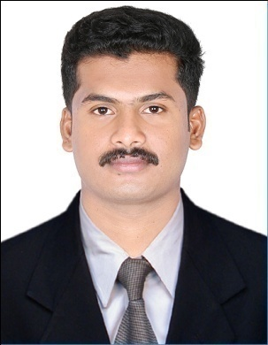

PRIYESH
E-Mail: PRIYESH.373610@2freemail.com

An enthusiastic & high energy driven professional targeting entry level assignments in business management field with an organisation of repute in Human resource and Marketing domain
Location Preference: UAE

PROFILE SUMMARY

- MBA ( Specialization –Human Resources and Marketing ) from Bangalore University, SAMBHRAM COLLEGE, Bangalore in 2014-2016
- Skilled in analysing & interpreting problems with a combination of trainings & projects experience and logical thinking to find the right solutions
- Proven interpersonal, communication and presentation skills, with the skills to work under pressure

ACADEMIC DETAILS

- MBA (Specialization – Human Resources and Marketing ) from SAMBHRAM COLLEGE, Bangalore, in 2016 with 60%
- BBA (Bachelor of Business Administration ) from DR. C.V RAMAN University College, 2014 with 65%
- 12th COMMERCE from HSE Board of kerala, INDIA WITH 60%
- 10th From Board of Kerala,, INDIA WITH 68%

E X P E R I E N C E

SALES PROMOTION EXECUTIVE ~ ORANGE ELECTRONICS, KERALA, INDIA (AUG- 2016 TO AUG-2017)
- Researching ideas,Markets
- Meeting clients and suppliers
- Creating marketing strategies including competition
- Sales incentives and sales promotion
- Ensuring that work proceeding under the plan
- Maintain all information about the clients and projects
- Preparation of bills and invoices

ACADEMIC PROJECTS

Project Title: A STUDY ON DIRECT MARKETING ON DEMAND OF SURABHI INTERLOCK INDUSTRY
COMPANY: SURABHI INTERLOCK INDUSTRY, KASARGOD, KERALA, INDIA
Period: march 1-april 30
Description: A detailed study on the effectiveness of direct marketing of surabhi interlocks industry

Project Title: A STUDY ON CUSTOMER SATISFACTION TOWARDS WHATSAPP

Duration: January 1- January 30
Description: A study on customer satisfaction in whatsapp

IT SKILLS

- ADCA ( Advanced Diploma in Computer Application )
Familiar with
- MS Excel
- MS Word
- MS power point
- MS Access
- BPO Training
- Scanning
- Printing
- Internet
- Formatting & installation

STRENGTHS

- Outstanding team player in all means and ways and have abilities worth contributing to increased synergy and output as leader/member.
- Possess leadership skills & maintaining good human relationship.
- Flexible and adaptable to changes and is open to new and creative ideas of working.
- Good qualitative aptitude along with excellent grasping power and zeal to learn.

PERSONAL DETAILS

Date of Birth: 03/06/1993
Languages Known: English, Malayalam, Hindi and Tamil
Marital Status: Single
Nationality: Indian
No. of Dependents: 0
Visa Status: U.A.E Visiting Visa
Visa Expire: 30/12/2017

Declaration:
I hereby declare that the above furnished details are true with proven records.

Date:
Sharjah , UAE

