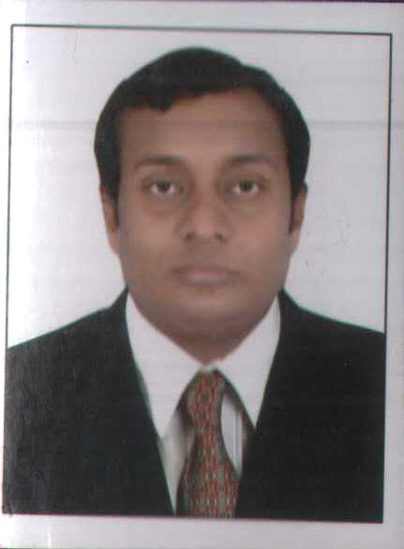

Mr. SURAJKUMAR
SURAJKUMAR.373612@2freemail.com

REGISTERED NURSE
DHA RN Passed on 20/07/2017

CAREER OBJECTIVE:
To pursue a nursing career in a professionally managed reputed organization where my knowledge and registered nurse skill can be effectively applied, enabling me to explore myself fully and realize my full potential with sincerity and dedication.

CAREER PROFILE:

Job Summary - 8.4 years

Organization - Apollo Hospitals International Ltd.
Gandhinagar, Gujarat.
Period - April 2009 till date
Position - Staff Nurse
Department - Surgical ICU and Liver Transplant ICU

DUTIES AND JOB RESPONSIBILITIES:

- Admit and Discharge Patients
- Maintain Personal Hygiene and comfort of Patients
- Provide Psychological Support
- Attend the Nutritional Needs of the Patients
- Daily Living Activities
- Maintain Clean and Safe Environment
- Ability to utilize patient management skils to enhance quality of services and patient satisfaction
- Administer prescribed medicines Intra Venous,Orally,through Ryles Tube,PEG Tube and FJ Tube

- Co-ordinating patients care with various health team members
- Follow Doctors Round and implement their plan of treatments
- Perform Technical Tasks
- Assisting Doctors in Various Medical Procedures
- Preparing Articles and Patients for Medical or Nursing Procedures

- Recording Vital Signs and detect any deviation from normal values
- Direct and supervise health care staff
- Preparing patients for various diagnostic procedures
- Help Doctors in Diagnosis and Treatment
- Maintain intake and output chart
- Observer changing patients condition and record
- Take necessary action and report to the concerned authority
- Attending and critically ill patients, post various surgical, Liver and Renal transplant patient care
- Health Education
- Implementation of therapy and subsequent follow up care
- Caring medical , surgical , cardiac oncology and neutopenic patients
- Maintain Dignity and Respect towards Patient and health care staffs

- Rehabilitation
- Conduct patient care teaching and Discharge Planning

PROCEDURES ASSISTED:

- Cardio Pulmonary Resuscitation
- Endotracheal Intubation
- Arterial- Venous Canulation
- Tracheostomy (Percutaneous and Open Tracheostomy)
- Lumbar Puncture
- Gastroscopy
- Colonoscopy
- Liver Biopsy
- Bone Marrow Aspiration
- Pig Tail Catheter insertion
- Central Venous Catheter insertion
- EVD insertion
- IABP catheter insertion
- Kidney Biopsy
- ICD insertion
- All major Dressing including Surgical and orthopedic Site, BURNS, Decubitus ulcer, COMMANDO Surgery, Wound and post Amputation
- Peritoneal Dialysis
- Bronchoscopy
- Pleural Tapping
- Preparing the patient for Coronary Angio Bypass Graft and Liver Transplant and various Surgery

EQUIPMENTS USED:

- Monitor
- Cardiac Monitor
- ETCO2 Monitor
- CVP Monitor
- ABP Monitoring
- ICP Monitoring
- IABP Monitering
- Suction Machine
- Central
- Portable
- Defibrillator
- Ventilator
- ECG Machine
- IABP Machine
- Pulse Oxymeter
- Syringe Pump
- Infusion Pump
- Laryngo Scope
- Blood Warmer
- Ambubag
- Glucometer
- Nebulizer
- B.P Apparatus

- NIV Machine portable
- Oxygen Cylinder

PROCEDURES I CAN DO:

- Emergency Resuscitation
- Suctioning
- Oral
- Nasal
- Tracheostomy
- Endotracheal
- Ryle’s tube Insertion
- Foley’s Catheterization
- Arterial Blood Gas Analysis
- Care of Unconscious Patients
- Immediate and Intermitted Post Operative Care
- Central Venous Pressure Monitoring
- ECG Monitoring
- Oxygen Administration
- Wound Dressing

- Nasogastric Feeding
- Gastric Lavage
- Blood Sugar Monitoring
- Care of Equipments
- Maintaining Records and Reports
- Administrating Medication and Intravenous Fluids

- Oral Medication
- Blood Transfusion
- Maintenance of Personal Hygiene
- Back Care
- Oral Care
- Hair Care
- Nail Care
- Foley’s Care
- Eye Care
- Sponging
- Bed making
- Dead Body Packing

EMERGENCY MANAGEMENT OF CRITICALLY ILL PATIENTS:

- Resuscitation
- Airway Clearance
- Ventilator Care

ACHIEVEMENTS:

- Working in a JCI accredited Hospital

ACADEMICS:
- Master of Business Administration (MBA) -
National Institute Business Management 2013

- BSc. Nursing - 2009
Ikon College of Nursing, Bangalore
Rajiv Gandhi University for Health Sciences, Karnataka.

- HSC (Biology) - 2004
G.H.S.S. Kunnam, Mavelikara
Board of Higher Secondary Examination, Kerala.

- SSLC - 2002
Mount Carmel Convent High School, Gandhinagar
Secondary Education Examination Board, Gujarat.

REGISTRATIONS:

- Issuing Authority - Dubai Health Authority
Position - Registered Nurse

DHA - EXAM passed on 20/7/2017

- Issuing Authority - Karnataka State Nursing Council
Position - Registered Nurse
Validity - Lifetime

CERTIFICATIONS:

- BLS (Basic Life Support Course)
Issuing Authority - American Heart Association
Validity - 18 February 2017 to 17 February 2019

TRAININGS ATTENDED:

- Attended various trainning classes for JCI
- Trainning classes for NABH
- Conferance on Safety and Risk for Health Care Proffessionals
- Basic Life Care Support
- Infection control
- Fire fighting

TECHNICAL EDUCATION:

MS-Office, Internet tools

LANGUAGES KNOWN:

- English - Professional working proficiency
- Hindi - Native / Bilingual proficiency
- Malayalam - Native / Bilingual proficiency
- Gujarati - Native / Bilingual proficiency

\
STRENGTH:

Hard working Professional
Disciplined and Punctual
Adaptable and Quick Learner
Team Player and Good Leader

PERSONAL & ADDITIONAL INFORMATION:

Age : 30 years (10-04-1987)
Gender : Male
Nationality : Indian
Marital Status : Married
Dependents : Wife (Bsc. Nurse), Mother

Declaration:
I hereby declare that the above furnished details are true to the best of my knowledge and belief.

